|  |
| --- |
| **Genesee Valley Central School** |
| DJI Phantom 2 Vision+ Quick Start Flight Manual |
| How to Fly and How it Works |
|  |
| **Jake R. Slaght** |
| **May 4, 2015** |

# Abstract

This is a detailed guide of how to configure and fly the DJI Phantom 2. This guide also contains the Quick Start guide within its documentation. Regulations of the FAA have been enclosed in regards to the how and what is required of the pilot to fly the drone.

Table of Contents

Abstract 1

Table of Figures 4

Introduction 6

Federal Aviation Agency (FAA) Regulations 7

Uses for GVCS 8

Academic Uses 8

Athletic Uses 8

Maintenance Uses 8

“Deconstruction” of the DJI Phantom 2 and Controller 9

The ‘Quick’ Guide Provided by DJI 9

The Phantom 2 Vision+ Drone 10

The Controller 11

The Extender 11

Comparing the Phantom I to the Phantom 2 12

The DJI Phantom I Drone 13

The Controller 14

The Camera 14

Pre-Flight 15

During Flight 16

Troubleshooting 17

Using the Camera 18

Appendix A: Pre-Flight Checklist 19

Night before Flight Day 19

Day of the Flight 20

At Location of Flight 21

Appendix B: Operating Drone during Flight 24

Setting a Home Point (HP) 25

To Change a Home Point during Flight 25

Setting and Using Course Lock (CL) Initially for Flight 25

To reset CL during Flight 26

How to Use Home Lock (HL) 26

Appendix C: LED/Sound Error Codes 28

Appendix D: Phantom 2 Software/NAZA-M Assistant Software 29

The Phantom 2 Software 29

The NAZA-M Software 31

Configuring the Intelligent Orientation (IOC) Settings 34

Appendix E: How to Use the Camera 35

Connect to the Camera 35

DJI’s Guide of how to use the Camera 35

Basic Use 36

Album Page 46

Appendix F: Advanced Techniques 48

Flying Curves 48

Regaining Control of the DJI Phantom while in the Air after a Fail Safe was initiated 48

Works Cited 49

QUICK START FLIGHT GUIDE 50

Quick Start: Pre-Flight Checklist 51

Quick Start: Operating Drone during Flight 56

Quick Start: LED/Sound Error Codes 60

Quick Start: Phantom Software/NAZA-M Assistant Software 61

The Phantom Software 61

The NAZA-M Software 63

Quick Start: How to Use the Camera 67

Connect to the Camera 67

DJI’s Guide of how to use the Camera 67

# Table of Figures

Figure 1: Phantom 2 Parts Provided 9

Figure 2: Phantom 2 Drone -- The Nose 10

Figure 3: Phantom 2 Drone -- The Rear (no battery) 10

Figure 4: Phantom 2 Drone – The Rear (with battery) 11

Figure 5: Front Face of the Extender 11

Figure 6: Left Side of the Extender 12

Figure 7: Phantom I Parts Provided 12

Figure 8: The Drone without camera mounted 13

Figure 9: The Drone with camera mounted 13

Figure 10: The Drone LED display shown 13

Figure 11: The Controller 14

Figure 12: Battery showing pins 19

Figure 13: Wall adapter -- Battery Connection 19

Figure 14: Proper Connection of battery to charger 20

Figure 15: Battery showing current power levels 20

Figure 16: Horizontal Setup of the Calibration Dance -- Yellow Light Revealed 21

Figure 17: Horizontal Holding, showing hand positioning 22

Figure 18: Starting the vertical calibration 22

Figure 19: Vertical holding -- showing arms to drone position 22

Figure 20: Starting motors 24

Figure 21: 3D Axis 25

Figure 22: Throttle Down -- Motor Kill Switch 25

Figure 23: LED Error Quick Reference Card 28

Figure 24: Phantom 2 Software Icon 29

Figure 25: Phantom 2 Software Splash Screen 29

Figure 26: Phantom 2 Overview 30

Figure 27: Phantom 2 Basic Tab 30

Figure 28: Phantom 2 Advanced Tab 31

Figure 29: NAZA-M Splash Screen 32

Figure 30: NAZA-M Overview Screen 32

Figure 31: Controller Settings 33

Figure 32: Failsafe Settings 33

Figure 33: Battery Settings 34

Figure 34: IOC Settings Screen 34

Figure 35: Battery showing pins 51

Figure 36: Wall adapter -- Battery Connection 51

Figure 37: Proper Connection of battery to charger 52

Figure 38: Battery showing current power levels 52

Figure 39: Horizontal Setup of the Calibration Dance -- Yellow Light Revealed 53

Figure 40: Horizontal Holding, showing hand positioning 54

Figure 41: Starting the vertical calibration 54

Figure 42: Vertical holding -- showing arms to drone position 54

Figure 43: Starting motors 56

Figure 44: 3D Axis 57

Figure 45: Throttle Down -- Motor Kill Switch 57

Figure 46: LED Error Quick Reference Card 60

Figure 47: Phantom 2 Software Icon 61

Figure 48: Phantom 2 Software Splash Screen 61

Figure 49: Phantom 2 Overview 62

Figure 50: Phantom 2 Basic Tab 62

Figure 51: Phantom 2 Advanced Tab 63

Figure 52: NAZA-M Splash Screen 64

Figure 53: NAZA-M Overview Screen 64

Figure 54: Controller Settings 65

Figure 55: Failsafe Settings 65

Figure 56: Battery Settings 66

Figure 57: IOC Settings Screen 66

# Introduction

The DJI Phantom I drone and GoPro Hero 3+ Camera purchased by the Genesee Valley Central School District (henceforth shortened to GVCS) has introduced a new level of technology to be introduced into the widely successful technological expansion of existing projects and technologies used by the school district thus far. The drone is capable of allowing a multitude of departments and students use it from a variety of potentional options within a secure and safe environment with strict supervision of well trained staff members of use in the drone’s operations.

The drone’s capabilities in the classroom allows the students and staff to dive head first into an emerging field only seen by highly trained professionals and allows them to gain an intimate understanding and a growing inspiration of the level of technique give for Aerial Photography.

The practical uses of showing mathematical equations to students allows for a better understanding of the information by placing it into a real world application allowing the students to take the information and retain it with a realistic understanding.

The company shipped guide provided little information and what was gathered by research, trial and error, and YouTube videos has been compiled and place within this document for and easy to access and read manual for use of the drone.

This document contains appendices for pre-flight, flight, camera use, NAZA-M software, and troubleshooting.

For Basic Quick Start instructions please utilize *Appendices A, B, C,* and *E*.

For more advanced techniques please see *Appendix F*.

# Federal Aviation Agency (FAA) Regulations

Before continuing on with the uses and the details of the document, there are a few things to bear in mind when reading this document.

The FAA requires that all flight time be done safely in regards to people, buildings, and animals. All flying must be done visually via line of sight, meaning that the camera cannot be used to maintain visual contact with the drone. This means that sufficient lighting and timing must be taken into consideration when flying the DJI Phantom I.

Please see *Appendices A* and *B* for detailed instructions of how to setup and fly the drone.

# Uses for GVCS

Drone usage for the school district can be used for several purposes: maintenance needs, educational lessons, and athletic training sessions. The only use currently sanctioned for use is the academic uses, the others listed as potential uses with permission and strict guidelines put into place to adhere to.

### Academic Uses

In the realm of academia the drone can be utilized in teaching classes on aerial photography techniques training and mathematics formulas (such as the quadratic equation). These advanced techniques in photography lessons can be used to teach the students how to catch a good idea of how to obtain a ‘bird’s eye view’ which are used in the Geology and Archeology fields (Mason).

In the realm of mathematics lessons the drone would be able to include real life applications of the quadratic formula, thus making the lesson more entertaining, engaging, and easier to remember the information taught. The quadratic formula is used to determine the path of a ball that is thrown or the placement of cables on a suspension bridge to thwart gravity’s pull. (Institute)

### Athletic Uses

Athletic departments can utilize the drone in regards to practices with explicit parental, board of education, and students’ permission. The drone’s aerial based video recording would allow coaches and athletes to see their weaknesses and strengths from a viewpoint similar to the Madden sports games commonly played by students on any number of gaming platforms. (Keilman)

This would require several heavy restrictions in regards to where it can be flown, how high it can be flown, the battery usage, time of day, and a direct understanding of all parties involved. As of right now, this is not recommended as a possible use for the Phantom I at the school district’s level.

### Maintenance Uses

A maintenance team could feasibly use the drone to video record and photograph locations that would be deemed hard to reach or unsafe to place a person on. The uses are endless though: checking for leaks, sagging roof, burst pipes, ventilation systems in question, unsafe ledges, or clogged rainfall systems. (Mason)

Currently this format of use would require line of sight control of the drone as is deemed necessary by the Federal Aviation Agency and therefore would place the safety of the pilot in question and is currently also an unfit way for the drone to be used currently.

# “Deconstruction” of the DJI Phantom 2 and Controller

The DJI Phantom 2 drone comes with the drone, built-in firmware installed, a RC controller, a battery, a wall charger for the drone battery, extra propellers, the NAZA-M software package to ensure proper configuration of the drone for flight use, and a quick user guide. The drone does come pre-configured out of the box to be flown immediately, but it advised to take into consideration the use of the NAZA-M software package provided and ensure all firmware is updated.

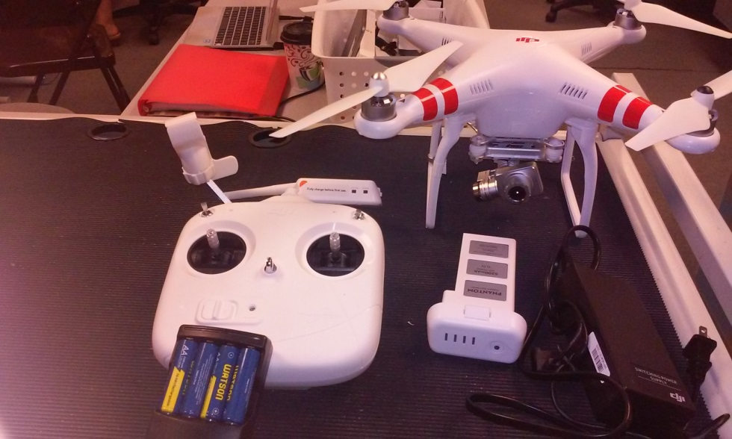

Figure 1: Phantom 2 Parts Provided

The Parts provided are: Controller with Extender and mobile device clamp, battery, drone with attached camera, ac drone battery power adapter

As with the Phantom I the Phantom 2 is a pretty standard system for RC drones, the additional capabilities of the Extender and having the built in camera makes use of the drone easier when it comes to configure and calibrating.

## The ‘Quick’ Guide Provided by DJI

A quick note on this guide, it is inadequate in regards of how to fly or operate the drone and utilize the NAZA-M software provided. The guide does provide a quick guide to the troubleshooting LED lights as a reference sheet. Please see *Appendix C* for that chart as well as explanation.

Most of the information provided in this guide is produced from extensive trial-and-error methodology, extensive researching via Google Search, Drone Enthusiast forums, and YouTube video searches.

It is highly recommended to append any information provided within this documentation with further found research as necessary.

For extensive and detailed use of the NAZA-M software please consult *Appendix D*.

## The Phantom 2 Vision+ Drone

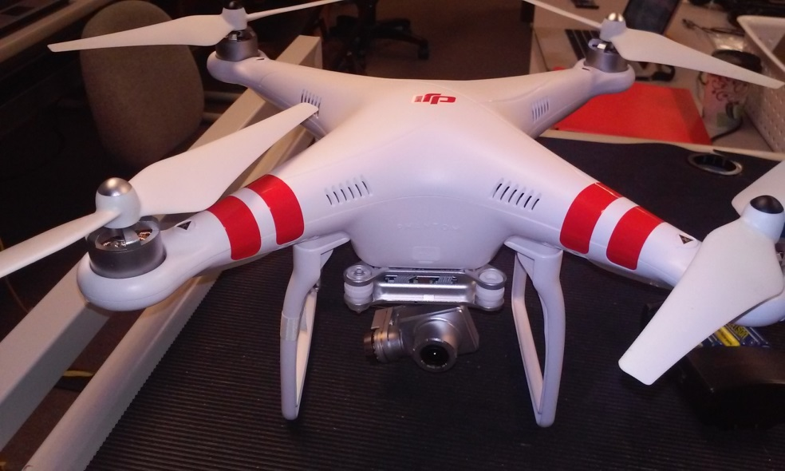

Figure 2: Phantom 2 Drone -- The Nose

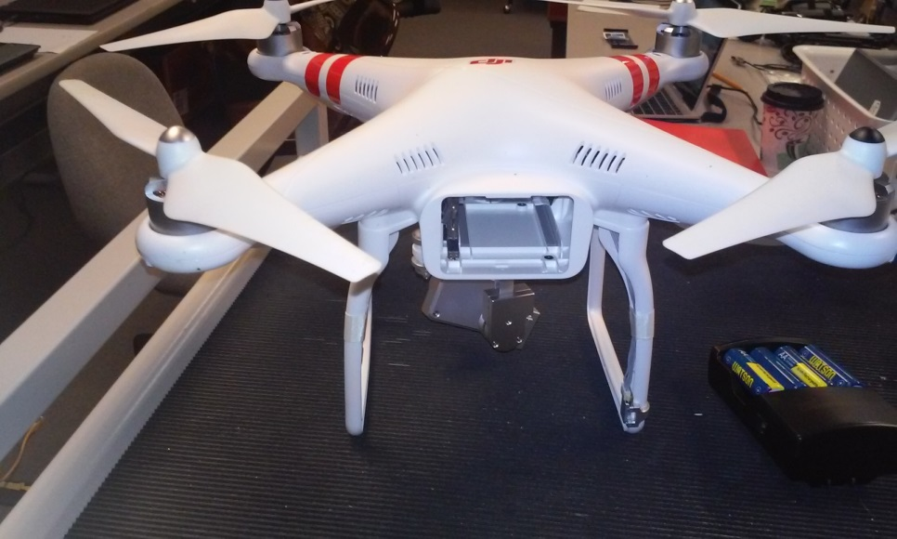

Figure 3: Phantom 2 Drone -- The Rear (no battery)

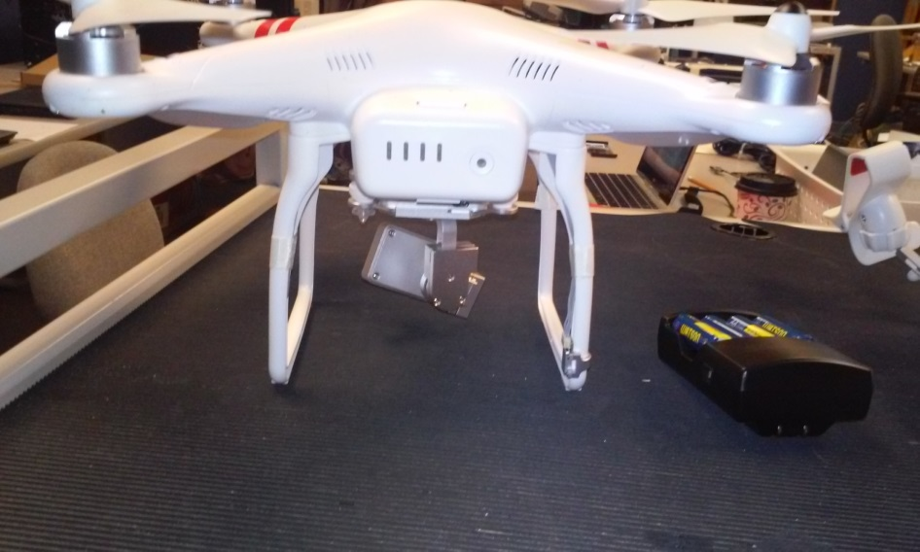

Figure 4: Phantom 2 Drone – The Rear (with battery)

Figures 2, 3, and 4 provide visuals of the bigger batter chamber, the larger body, bigger propellers, the built in camera, and the chance in battery connection to the drone itself.

## The Controller

The controller is exactly the same as the first generation drone, minus a few slight changes. On the Phantom 2 drone the Course Lock/Home Lock toggle switch is called the S1 toggle and the GPS/ATTI/ATTI toggle switch is called the S2 toggle. The real change is on the hardware attached to the controller as seen in Figure 1.

## The Extender

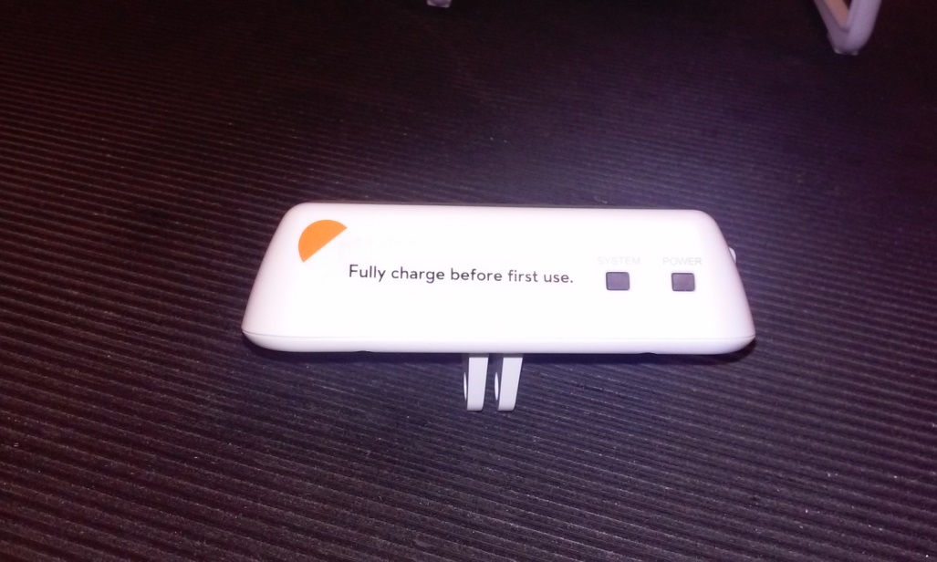

Figure 5: Front Face of the Extender

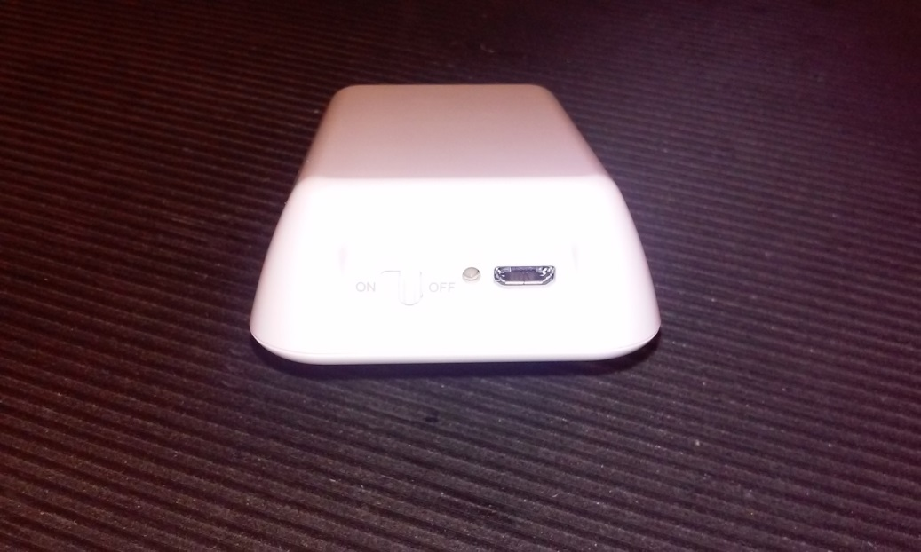

Figure 6: Left Side of the Extender

Figures 5 and 6 show the only necessary sides required for functional use of the mechanism known as the Extender. Figure 5 are the LED indicators showing the power of the extender is on/off and the system LED shows whether the connection is ready for syncing the camera to the application controller. This mechanism is nothing more than a bridging wireless connection that relays information between software and camera and has a longer range than the 3rd party entity used with the Phantom I.

## Comparing the Phantom I to the Phantom 2

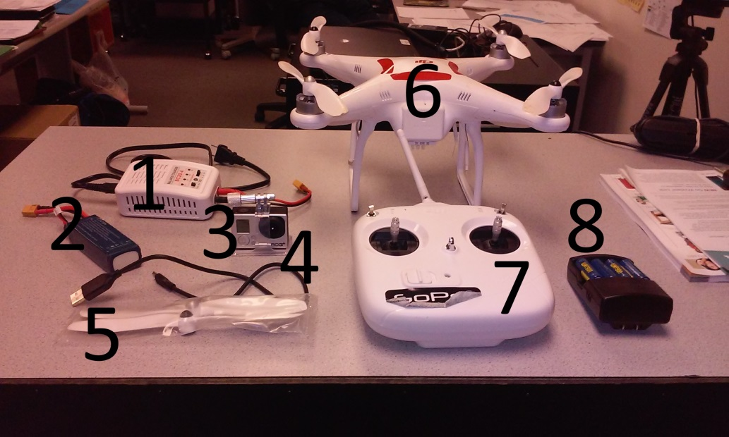

Figure 7: Phantom I Parts Provided

Contents Shown: 1. Wall Charger for Drone Battery; 2. Drone battery; 3. GoPro Camera Hero 3+*; 4. USB cable for camera*; 5, Extra propellers; 6. DJI Phantom I drone; 7. RC Controller; 8. Controller batteries and wall charger*.

*NOTE: Sold Separately.

(source: Author)

### The DJI Phantom I Drone

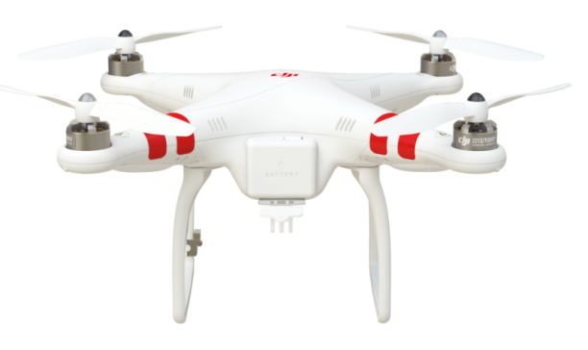

Figure 8: The Drone without camera mounted

(source: http://www.dji.com/product/phantom/feature)

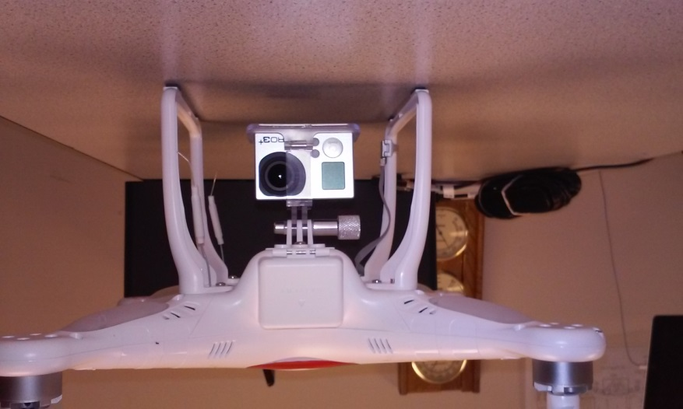

Figure 9: The Drone with camera mounted

(source: Author)

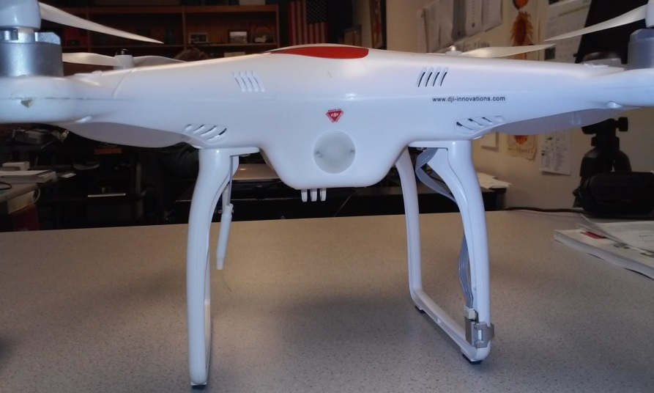

Figure 10: The Drone LED display shown

(source: Author)

This drone is classified as an Unmanned Aircraft System – henceforth known in this document as an UAS – by the Federal Aviation Agency (Administration).

The drone itself is a quadcopter, meaning is has four individualized motorized rotors. Each rotor is powered by an individually powered motor that adjusts speed to allow for the flying forward, backwards, up, down, left, and right of the drone.

The landing gear is a simple set of ‘legs’ that protect the main body of the drone and therefore the electronic equipment housed inside.

### The Controller

The controller consists of dual analog system used to control the drone’s flight operations and two toggle switches used for GPS based systems and GPS/Compass calibration setup.

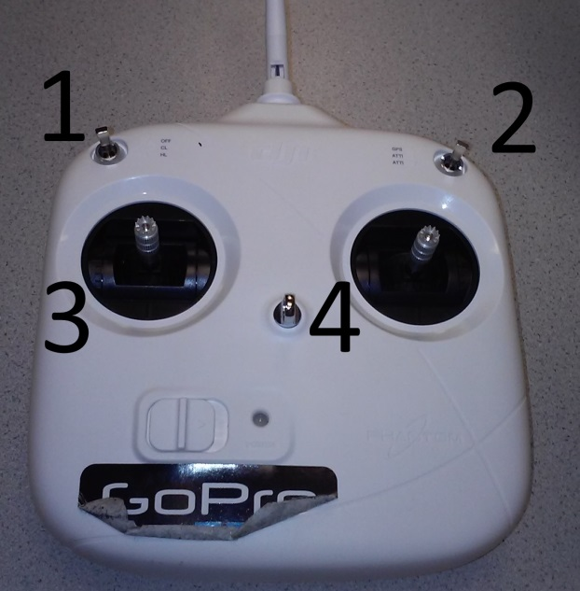

Figure 11: The Controller

Contents Shown: 1. HomeLock/CourseLock toggle; 2. GPS/ATTI/ATTI toggle; 3. Throttle; 4. Directional.

(source: Author)

The controller is pretty self-explanatory for use. Throttle controls the altitude of the drone giving it lift. The directional means the direction in which the pilot wants to move the drone: forward, backwards, left, or right. The controller takes 4 AA batteries, Figure 1, the item marked 8 shows the batteries housed in their charger. The batteries are placed within the controller on the underside, image not taken

### The Camera

Shown in Figure 1, the camera is a GoPro Hero 3+ and is used to take high-definition photos and videos. Though capable of taking live-feed footage and streaming it to a website, this is not recommended due to the technical difficulties with the Hero 3+ and does not affect the use of the camera in this circumstance.

# Pre-Flight

The pre-flight setup for the drone is a preventative setup allowing for a more satisfying and enjoyable flight experience. There is no mistake that being prepared is a major component of life and drone flight is no exception. *Appendix A* goes into the step by step setup that works well for the school’s currently owned drone.

*Appendix D* is also important to take into consideration every so often for the pre-flight checklist to check the configuration, firmware for the controller and the drone, as well as the occasional run through of the IOC setup, failsafe mechanism with effect of a low charged battery.

Some of the pre-flight setup is done during the day of the flight: double checking of weather conditions, calibration of the compass and GPS systems of the drone. Any errors thrown at this time can be examined and resolved by taking a look at *Appendix C*.

By following the pre-flight setup issues with failure to sync the controller to the drone, drone battery low error code, or no power to the controller can be resolved beforehand and therefore not occur.

*Appendix E* allows for thorough control of the camera and that also plays a part in the current setup of the pre-flight allowing for configuration of the proper devices, installation and gaining of camera control via said device, as well as maintains full access to the camera via the Extender.

# During Flight

Flight control needs to be taken cautiously as the guide from DJI failed to even acknowledge how to start the flight protocols as well as the setup of the drone’s failsafe protocols and low voltage situations this guide is meant to fill in any gaps that occur.

The quick start portion of this guide contains the how to start the flight control, as well as the setting up of the Intelligent Orientation Control system needed for Home Lock and Course Lock functionality via the NAZA-M software (see *Appendix E*).

Taking heed of the FAA regulations for flying a drone must be taken into serious consideration when flying the drone, a line of sight is required at all times, the pilot should not be controlling the wireless device’s camera taking functions well at the same time as flying due to the multi-tasking removing attention from the direction, speed, and altitude. This also includes any and all audio/LED based error codes that may be emitted at any time (see *Appendix C* for error codes).

# Troubleshooting

Just like with any technological devices troubleshooting is an important part of the system of control and integrity of the device in question. Due to the nature of the drone and the FFA regulations most of the error codes created by the creators of the Phantom 2 were done via LED displays on the drone itself as well as audio beep codes not far off from a computer’s beep codes for error codes.

*Appendix C* is the primary source of the noted errors deemed important by DJI a note should be made that this list is far from extensive and their guide provides no solutions. Research is recommended in due case that any of the errors have not yet been given a solution to. Currently all research done for troubleshooting and the filling out of this document has been done through trial and error runs and extensive YouTube searches looking for specific videos, any of the utilized videos and documents have been cited in the Works Cited with links provided.

Luckily DJI learned from the previous generation’s mistakes and attached a quick reference card of the LED errors right to the controller for use while in the field.

# Using the Camera

Using the camera is recommended to be done by a secondary person with a mobile device. Due to FAA regulations require full attention and line of sight conditions for flying the pilot is unable to attend to the necessitates of camera capabilities with the current system provided by the school at this time. With the DJI VISION software used to control the drone’s camera it also gives additional information that may prove useful to the pilot.

The DJI VISION software gives visual via the camera, altitude, direction, wind speed, and drone speed while in flight.

*Appendix E* and the Quick Start Guide will have information on how to setup and use the camera via the application.

# Appendix A: Pre-Flight Checklist

The pre-flight checklist is important as most of the flight related issues can be handled before a flight demonstration.

### Night before Flight Day

1. Ensure the Weather is going to be flight capable
   1. High winds, cold temperatures, low visibility and precipitation of any sort will halt flying the DJI Phantom immediately.
2. Plug in battery into wall charger and allow it to charge overnight.

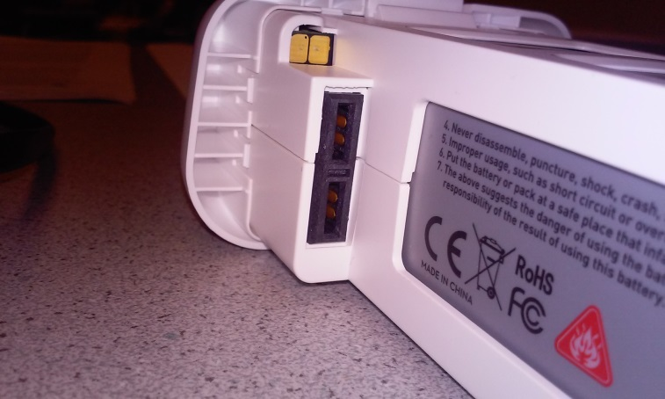

Figure 12: Battery showing pins

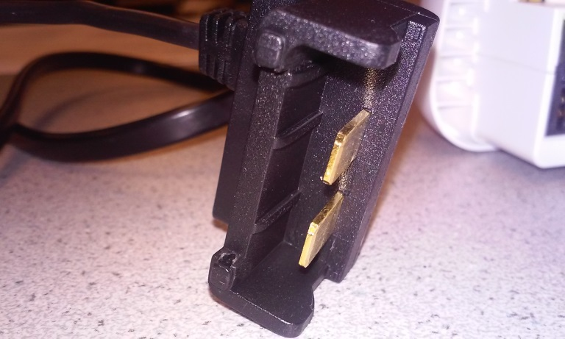

Figure 13: Wall adapter -- Battery Connection

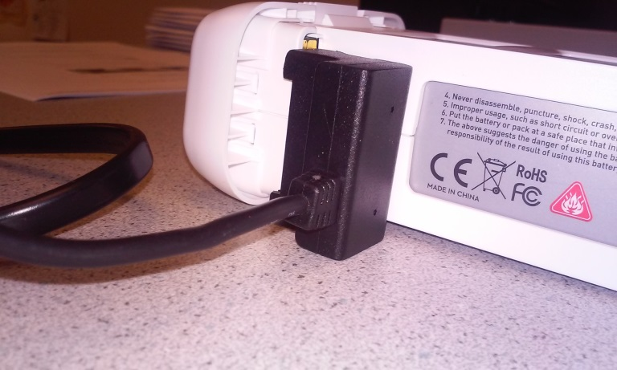

Figure 14: Proper Connection of battery to charger

(source: Author)

1. Plug in charger for controller batteries into wall and place batteries in it.
2. Plug and Charge the iPad being used for DJI VISION software
3. Turn on a laptop and ensure it will remain logged in and on.
4. Plug the camera into the laptop for charging.

***\*NOTE* Allowing the battery to charge overnight ensures full charger for a morning flight. Acquire a total of three mini USB charge cables for the charging the camera, for the drone and t`he remote for updating purposes***

### Day of the Flight

1. Make note of current weather conditions
   1. If weather is bad postpone to the afternoon or the following day.
      1. Bad weather constitutes as rain, snow, high winds
2. Double check the drone battery is full charged
   1. Press the button on the front of the battery for a second the lights will flash up the power currently
      1. Battery must be unplugged from the wall charger to perform

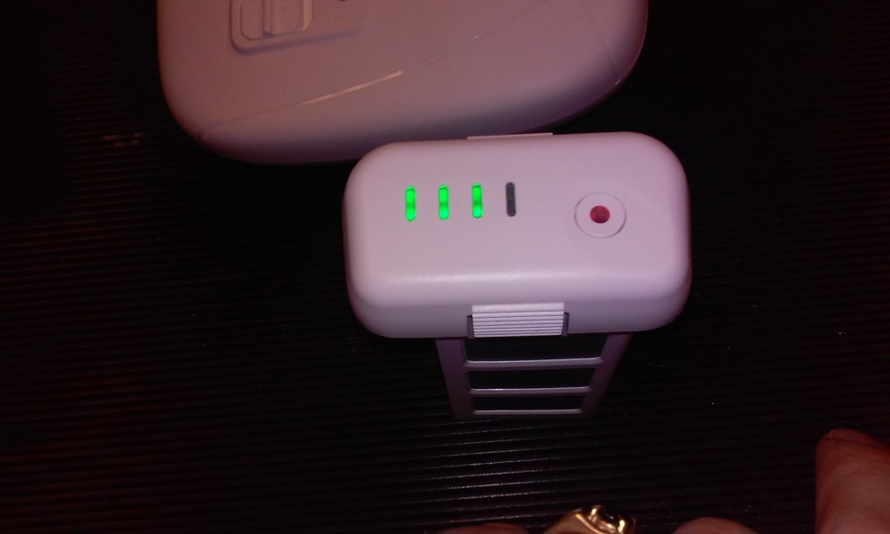

Figure 15: Battery showing current power levels

1. Unplug and bring along all the charged batteries and camera.
2. Bring the Drone, iPad, batteries, and controller
3. Install the controller batteries now, do not install drone battery or turn on the controller until at location
4. Locate a wide open area with minimal buildings, electrical, or metal based structures as they will interfere with the configuration and calibration of the drone.
5. Refer to *Appendix E* for use of the camera

### At Location of Flight

1. Place the drone on flight level ground and place the controller down as well.
2. Turn on the controller
   1. The controller must be on prior to powering up the drone for the drone and the controller to sync correctly to one another
3. Install battery into drone
   1. Press the battery button once and release
   2. Press and hold the battery button until it chirps, about five seconds
   3. If issues persist – Lights flashing red or beep codes please look at *Appendix C*.
4. Make sure all switches on the controller are positioned correctly
   1. The HomeLock/CourseLock switch on the left side should be set to ‘Off’
   2. The GPS/ATTI/ATTI switch on the right should be set to ‘GPS’
5. On the controller toggle the GPS/ATTI/ATTI switch 6 to 10 times until the LED light on the drone is a solid yellow-orange (here on out will be declared ‘Yellow’) and the toggle switch is on GPS
   1. This step should be done slowly to ensure switch ends correctly, otherwise repeat until correct
6. Perform the ‘Calibration Dance’ Ritual
   1. Pick up the Drone carefully so it is still horizontally positioned with arms out.

*\*NOTE* The images shown below are original images from the Phantom I documentation.*

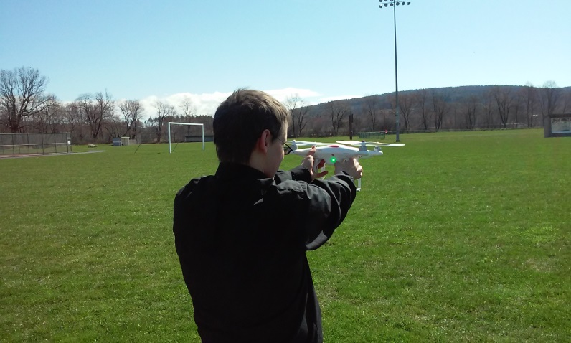

Figure 16: Horizontal Setup of the Calibration Dance -- Yellow Light Revealed

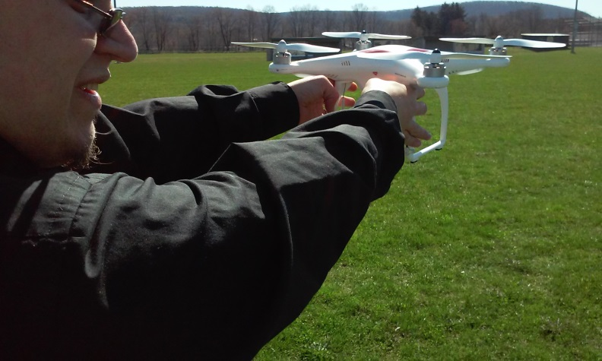

Figure 17: Horizontal Holding, showing hand positioning

* 1. Very slowly walk in a counter-clockwise circle until the LED lights on the arms on the drone turns a solid Green
  2. Turn the drone vertically holding the legs and the camera is pointing to the ground

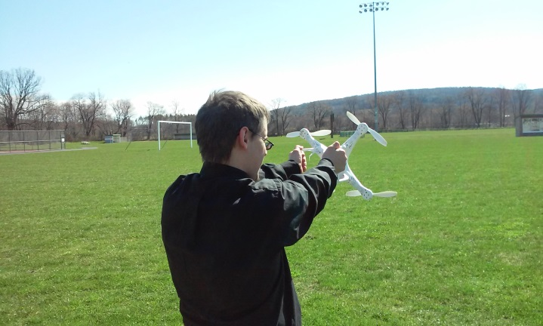

Figure 18: Starting the vertical calibration

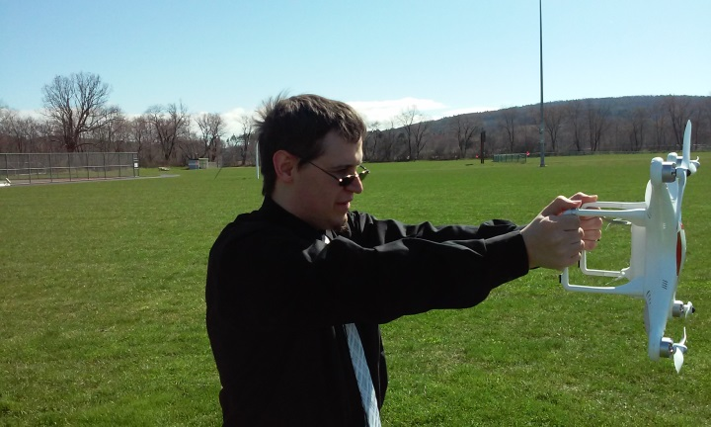

Figure 19: Vertical holding -- showing arms to drone position

* 1. Very slowly walk in a counter-clockwise circle until the LED lights on the arms flashes yellow

1. Set down the drone and allow the GPS system and the satellites to sync.
   1. This step can take several minutes to complete, the light sequence is listed in *Appendix C*.
2. You are now ready for flying the DJI Phantom 2 drone
   1. Refer to *Appendix B* for Operating the Drone during Flight
3. If using the camera turn on the Extender.
   1. See Appendix E for configuration on the iPad and use.
4. Enjoy and Be Safe!

***\*NOTE* Video Guide of Pre-Flight Drone Operation provided, go to: [insert link]***

# Appendix B: Operating Drone during Flight

Once the Pre-Flight setup has been completed and the drone is ready to fly the steps below are fairly simple and probably the easiest to handle!

**\*IMPORTANT* See *Appendix E* in how to use the Camera**

*\*NOTE* The images shown below are original images from the Phantom I documentation.*

1. Start the Motors
   1. Pushing both joysticks down in opposite outside corners works best
      1. Throttle down and to the left
      2. Directional down and to the right

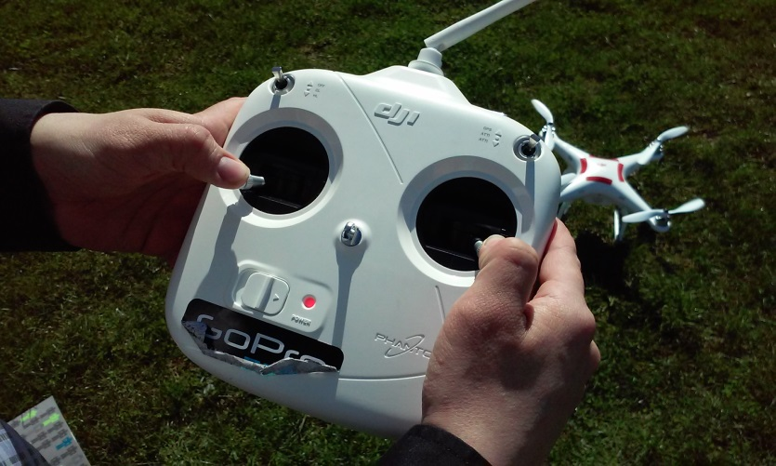

Figure 20: Starting motors

* 1. nce motors start, release the joysticks so they return to the center
  2. Allow the motors and rotors to spin for several seconds
  3. If any sounds or the motors slow down and stop spinning please review *Appendix C*

1. Once motors are going without issues ready for flight
2. Slowly apply upward pressure to the Throttle
   1. The motors will make a lot of noise at this point – this is normal
   2. Continue to apply throttle until drone starts lifting off the ground.
   3. Once drone is off the ground, applying more pressure will send it up into the air higher

After the above steps, the following steps are more of how-to move the drone

***\*NOTE* The direction of flight is determined by the direction of the nose of the drone. If nose is facing towards the pilot, the directional orientation is reversed and the left and right spins on throttle are reversed. Drone facing left the directional orientation is rotated 90° to the left. Drone facing right the directional orientation is rotated 90° to the right. See Course Lock functionality below.***

1. To Hover: Release the throttle, the drone will remain in a hover state as long as the wind isn’t too strong. It may move slightly.
2. To turn the drone around in either the left or right along it’s z-axis (up and down): Push the throttle stick to the left or right.
3. To move forward or backwards along the x-axis: Push the directional stick forward or pull it back
4. To move left or right on the y-axis: Push the directional stick left or right.

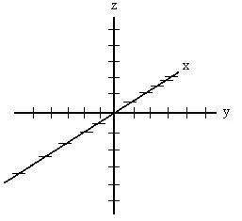

Figure 21: 3D Axis

*(source:* (deepimpact.umd.edu)*)*

1. To Land: Slowly pull the throttle down until the drone lands on the ground, keep the stick down, adjusting the directional stick as needed to keep the drone stable
   1. Keep the throttle stick pulled downward until the motors stop running.

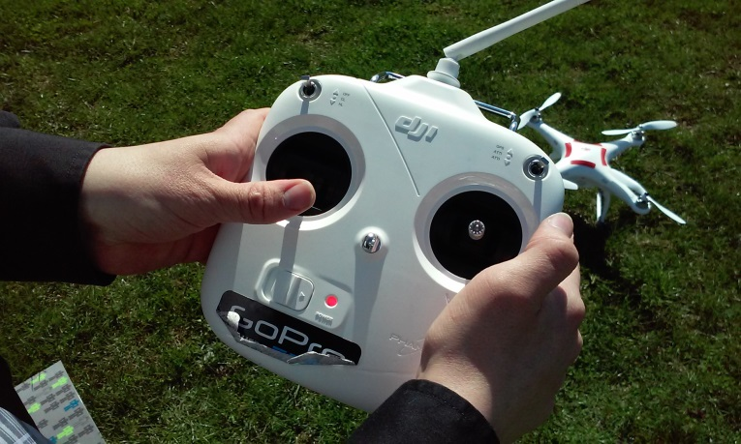

Figure 22: Throttle Down -- Motor Kill Switch

### Setting a Home Point (HP)

A home point is the location in which the drone will use as a home base for the Course Lock and Home Lock functions. The starting home point of any initial flight is the starting location of the controller. (Time, #7)

### To Change a Home Point during Flight

1. Find new location clear of pilot
2. Toggle CL/HL switch between CL and HL 5 times. (Time, #7)

### Setting and Using Course Lock (CL) Initially for Flight

Course Lock allows for the pilot to have the same directional control of the drone regardless of the nose’s physical pointing direction.

**\*IMPORTANT* CL can only be used within a 16 to 32 foot radius circle of the Home Point.**

To set the CL initially while in the field the pilot does the following:

1. With drone and controller off place the nose of the drone in the direction desired for forward.
2. Turn on the Drone and Controller in the fashion mentioned above
3. Allow GPS to sync to drone
4. Toggle the CL/HL toggle to CL and wait for the yellow flashing with green
5. CL is now set
6. To fly with CL now set toggle to off
7. Fly as normal

**\*IMPORTANT* Course Lock allows the pilot to use the same directional and spin directions of the throttle regardless of direction of the nose of the drone.**

*Source:* (Time, #5)

### To reset CL during Flight

With the drone in flight and the pilot wants to shift the directional controls for easier orientation between the controller and the drone

1. Toggle CL On and Off 5 times until a flashing green light appears.
2. Return the toggle to Off
3. Fly as normal

*Source:* (Time, #5)

### How to Use Home Lock (HL)

Home Lock allows for drone to return to the home. The location of the ‘home point’ is the location of the controller’s coordinates.

***\*NOTE\****

1. ***Home Lock is not for Failsafe control.***
2. ***HL is not automatic***
3. ***HL does not care about orientation of the drone, it will return towards the HP.***
4. ***HL only works outside of the CL range***

To use Home Lock the pilot would toggle the CL\HL to HL and pull down on the directional stick.

*Source:* (Time, #7)

**\*IMPORTANT* At any time the drone becomes out of the range of the controller, batteries run low on the drone the drone will enter a Fail Safe protocol which will send the drone back to the current home point.**

**\*IMPORTANT* If the pilot feels uncomfortable with the drone’s current flight patterns or loses sight of the drone see below about Home Lock**

***\*NOTE* The GPS location of the starting point is not 100% accurate due to the technology in use of the GPS system of the drone.***

***\*NOTE 2* To set Course Lock or Home Lock please see Appendix D on how to set the Intelligent Orientation Control settings in the NAZA-M software***

**\*IMPORTANT* See *Appendix F* for Advanced Techniques**

***\*NOTE* Video Guide of Drone Flight Operation provided, go to: [insert link]***

# Appendix C: LED/Sound Error Codes

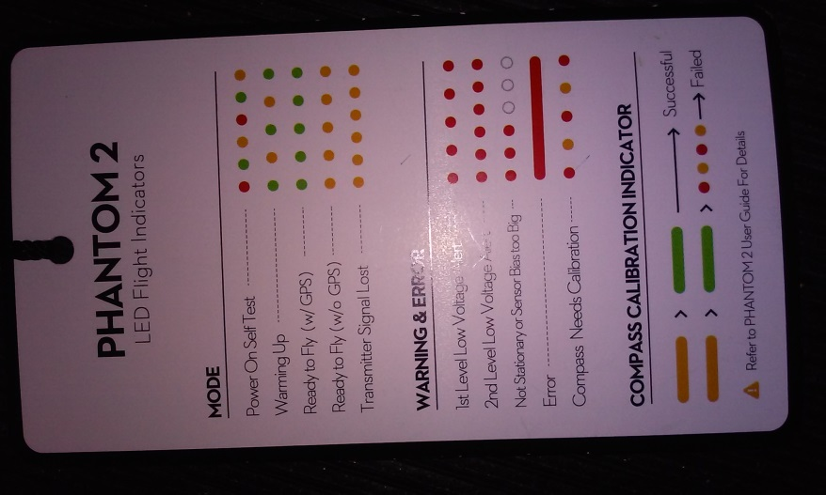

Figure 23: LED Error Quick Reference Card

Figure 23 depicts the attached reference card that DJI provided with the controller for the Phantom 2. This is a huge change since the Phantom I due to the use of having something for in field use. The Phantom I did come with the LED codes but they were only contained within the start guide or available extensively online at the DJI website. The Phantom 2’s codes are also provided on their website and in the guide provided, but the reference card makes it easy for on field reference card.

# Appendix D: Phantom 2 Software/NAZA-M Assistant Software

## The Phantom 2 Software

Unlike the DJI Phantom I the second generation drone has its body of software that provides basic system setup for just the drone itself. To setup the Intelligent Orientation Controls and Fail Safe Settings please use the NAZA-M. The NAZA-M is now accessible for the Phantom 2 via selecting the word ‘Phantom’ as seen in Figures 25 to 28 – Read the below NAZA-M section for how to use the NAZA-M.

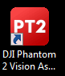

Figure 24: Phantom 2 Software Icon

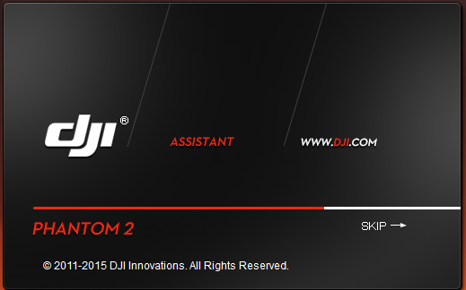

Figure 25: Phantom 2 Software Splash Screen

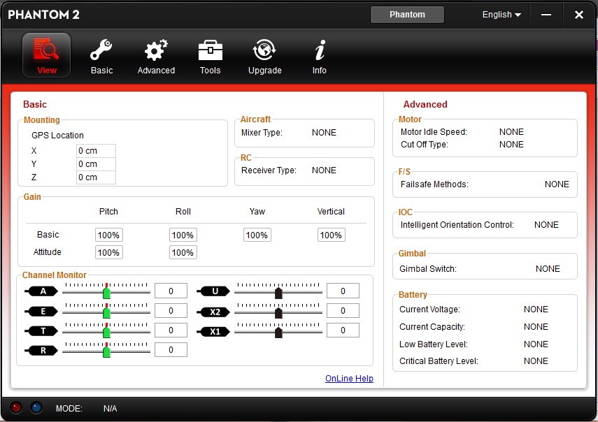

Figure 26: Phantom 2 Overview

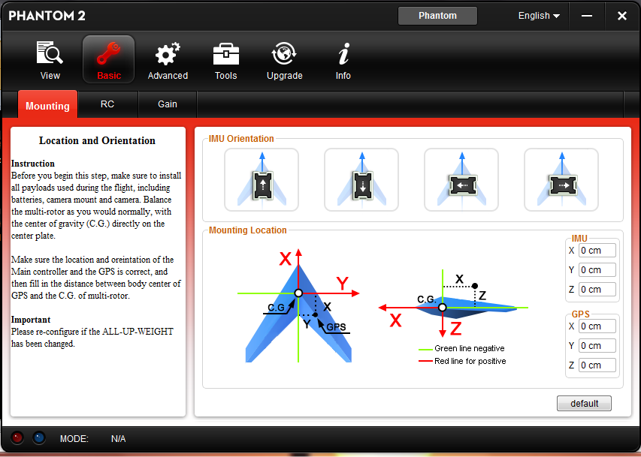

Figure 27: Phantom 2 Basic Tab

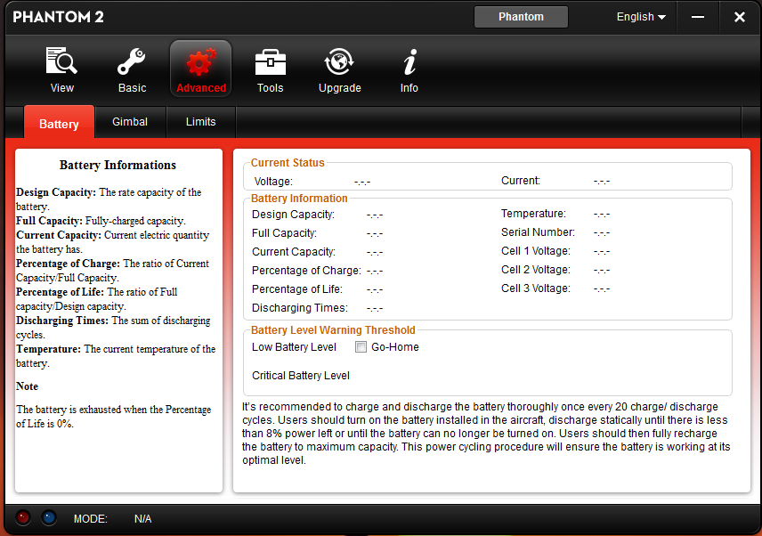

Figure 28: Phantom 2 Advanced Tab

Figures 26 to 28 provide basic information on how to setup the drone’s Gimbal, Limitations, Battery Overview, Controller, and basic configuration settings. The Battery Tab as seen in Figure 28 only provides an overview; it does not provided much in the way of configuration there besides the ‘Go-Home’ option.

## The NAZA-M Software

The use of the NAZA-M Software for the Phantom 2 requires the same settings as the Phantom I. The NAZA-M requires the controller to be connected to the drone. This implies power to the Drone and the controller (See *Appendices A and B* for details of connecting the controller to the drone). In addition to that connection please be sure to connect the drone, controller, and camera right to the laptop for software update control.

*NOTE* There is only a single USB available at the time of writing this, please ensure that the user has enough cables available to ensure all devices are connected.

For the Phantom 2 the NAZA-M software is used for more advanced settings such as the IOC.

1. Open the NAZA-M software

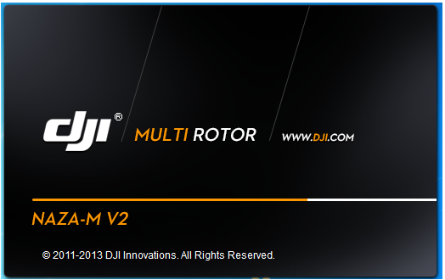

Figure 29: NAZA-M Splash Screen

(source: Author)

1. Upon boot up of the NAZA-M the user gets an over view of all settings

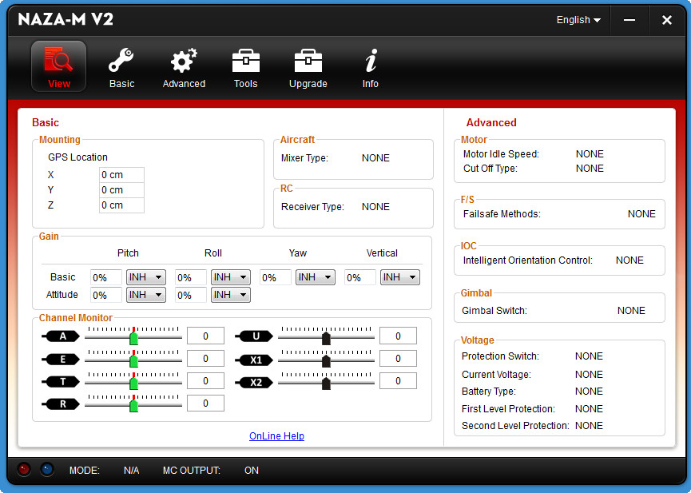

Figure 30: NAZA-M Overview Screen

(source: Informer (Informer))

1. The user can ensure the calibration of the controller for fine tuning control under the Basic Tab and RC
   1. In Figure 11 the following labels correlate to the following toggle switches and joysticks of the controller:
      1. A : Directional
      2. E: Directional
      3. T: Throttle
      4. R: Throttle
      5. U: GPS/ATTI/ATTI
      6. X1: HL/CL toggle
      7. X2: GPS/ATTI/ATTI toggle

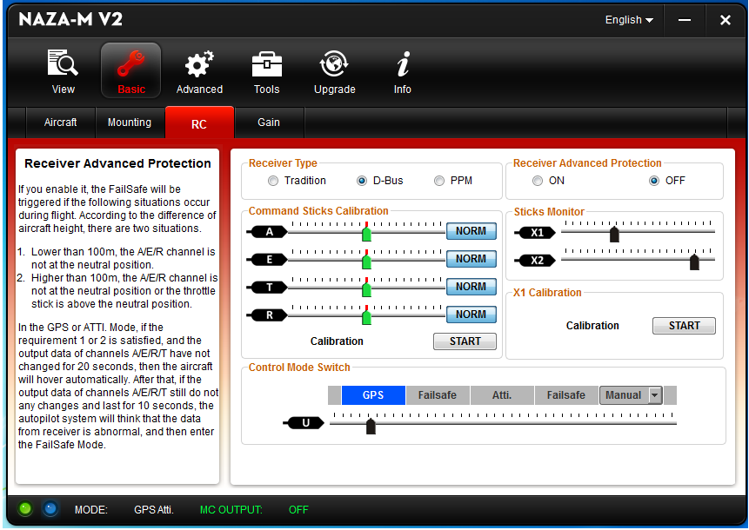

Figure 31: Controller Settings

(source: Author)

1. To set the Intelligent Orientation Control settings for Home Lock and Course Lock the user accesses the Advanced tab under To allow for the drone to return upon battery dying or the loss of controller communication the user accesses the Failsafe Settings under the Advanced Settings.
   1. This setting also plays hand in hand with the battery settings the user can locate under Advanced > Voltage

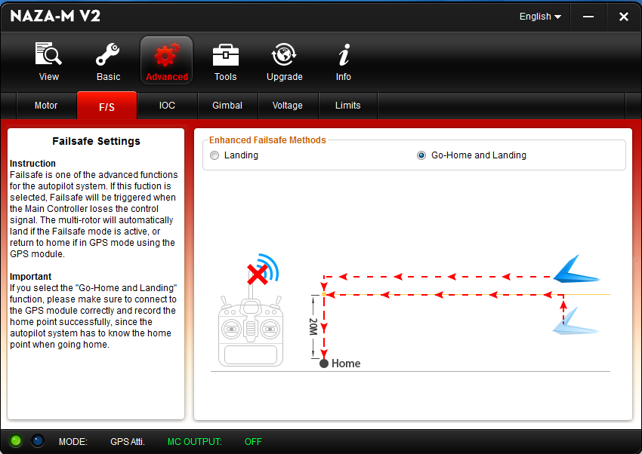

Figure 32: Failsafe Settings

*(source: Author)*

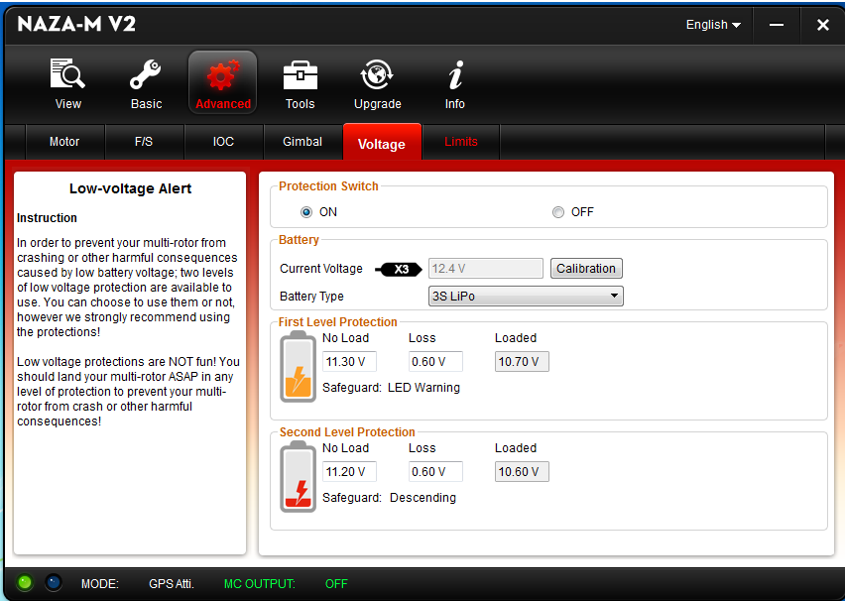

Figure 33: Battery Settings

(source: Author)

### Configuring the Intelligent Orientation (IOC) Settings

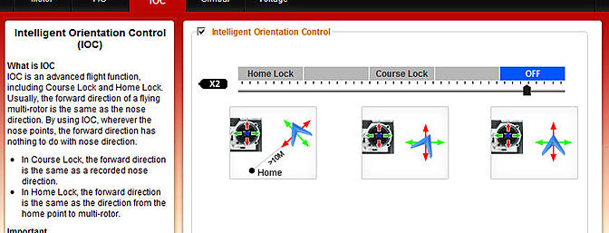

Figure 34: IOC Settings Screen

*(source:* (RCGroups)*)*

The IOC settings are required to utilize the Home Lock and Course Lock functions during flight usage. See *Appendix B* for Home Lock and Course Lock control.

The only step required to configure the IOC is to check the box for it at the top.

* The X2 indicated is the CL/HL toggle switch found on the controller, if toggled the slider will indicate the setting selected within the software.

# Appendix E: How to Use the Camera

Connecting the drone’s camera to the iPad is an extremely easy process, controlling the camera is a different story entirely when comparing it to the GoPro and the Phantom I.

## Connect to the Camera

Follow the steps found in Appendix A of setting up the drone for flight. Prior to taking off turn on the Extender via the power switch on the side of it.

The Phantom 2’s wireless system for the camera is ***Phantom_JaguarVision***.

Follow DJI’s guide below for how to use the device, it is actually really good

## DJI’s Guide of how to use the Camera

The following write up how to use the camera comes from the DJI Wiki Page concerning the Camera. The author takes no credit of writing it. Anything inputted by the author will be marked with a bolded **Author:** marking.

*(source:* (DJI, 2014)*)*

After login you will come to the main page. This shows the current Wi-Fi connection and four app function icons.

[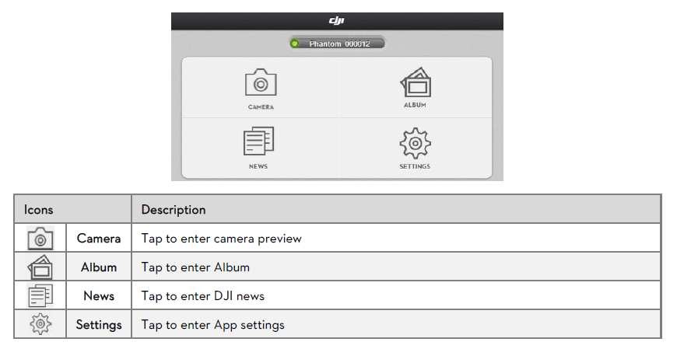](http://wiki.dji.com/en/index.php/File:P2v-App_Main_Menu.png)

**Caution**

1.Connect your mobile device to the PHANTOM 2 VISION Wi-Fi network to use the camera and onboard album.

2.Connect your mobile device to the internet (mobile or Wi-Fi) to share photos,videos and read DJI news.

3.If you receive a phone call during flight, the live camera preview screen may be interrupted. It's recommended to ignore the call and pay full attention to your flight. **Author: This is not going to be a problem, disregard. GVCS uses an Apple iPad**

### Basic Use

[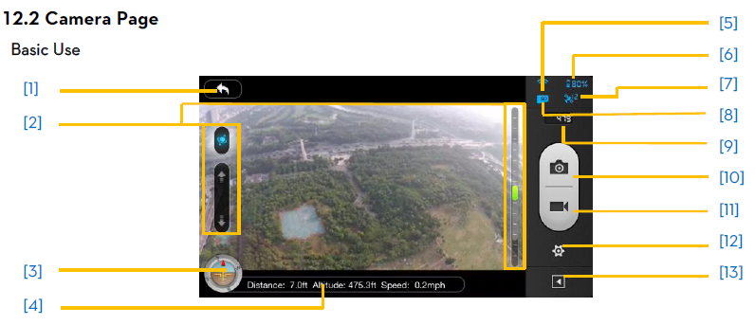](http://wiki.dji.com/en/index.php/File:P2v-Basic_Use.png)

[1] **Return**

[](http://wiki.dji.com/en/index.php/File:P2v-return.png) - Return to the preview page

[2] **Camera Tilt Control**

[](http://wiki.dji.com/en/index.php/File:P2v-tilt.png) - Tilt Control Mode. Tap and hold to enter the Accelerometer Sensor Mode.Release to return to normal mode.

[](http://wiki.dji.com/en/index.php/File:P2v-tilt.png) **Normal Mode**

Tap up arrow ([](http://wiki.dji.com/en/index.php/File:P2v-tilt_up.png)) to pitch camera upwards and down arrow ([](http://wiki.dji.com/en/index.php/File:P2v-tilt_down.png)) to pitch downwards. Green slider indicates current camera pitch.

[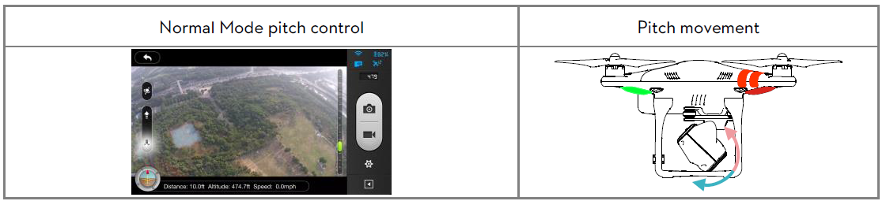](http://wiki.dji.com/en/index.php/File:P2v-tilt_mode.png)

[](http://wiki.dji.com/en/index.php/File:P2v-tilt_on.png) **Accelerometer Sensor Mode**

Tap and Hold to switch on Accelerometer Sensor Mode to control camera pitch and rotation by moving your mobile device.

Tilt device forward to pitch camera downward and backward to pitch upward. Lean it left to rotate left ([](http://wiki.dji.com/en/index.php/File:P2v-turn.png)) and right to rotate right ([](http://wiki.dji.com/en/index.php/File:P2v-turn.png)).

[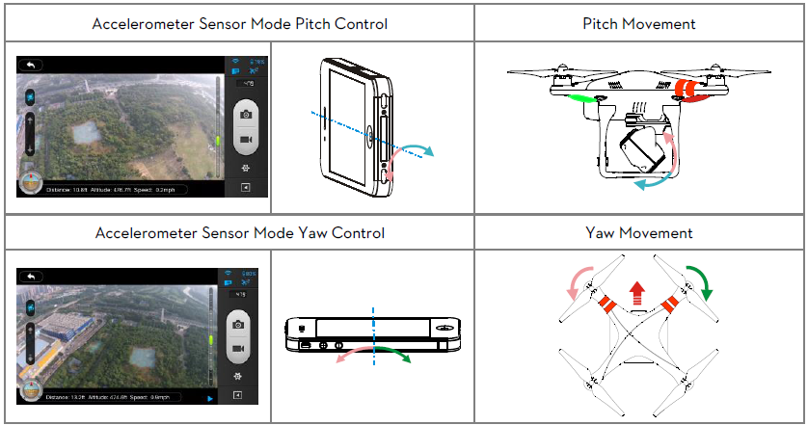](http://wiki.dji.com/en/index.php/File:P2v-tilt_motion.png)

**Caution**

In Accelerometer Sensor Mode, the pitch angle indicator will show a grey area. When the green pitch indicator is inside the grey area, the camera will move according to pitch gestures. When the indicator is outside of the grey area, pitch gestures will control the camera’s pitch speed. The bigger the gesture of the mobile device, the faster the camera will move.

[3] **Flight Attitude and Radar Function**

Flight attitude is indicated by the flight attitude icon.

(1) The red arrow shows which direction the PHANTOM 2 VISION is facing.

(2) Blue and brown areas indicate its pitch.

(3) Tilting of the brown and blue area shows roll angle.

[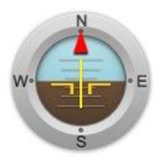](http://wiki.dji.com/en/index.php/File:P2v-Radar_Function.png)

Tap the flight attitude icon to turn on the radar function. Home is located in the center of the radar and the red icon indicates the PHANTOM 2 VISION’s current heading, direction, and approximate distance from home. Tap the flight attitude icon again to disable the radar.

[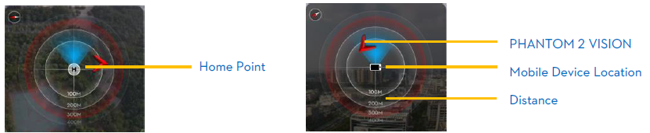](http://wiki.dji.com/en/index.php/File:P2v-Radar_Function1.png)

**Caution**

1.By default, the center of the radar indicates the home point that has been recorded by the PHANTOM 2 VISION. Tapthe center of the radar to switch the center to your mobile device's current location.

2.If your mobile device contains a compass, the top portion of the Radar is the direction you are pointing. If not, the radar will be oriented due north.

[4] **Flight Parameters**

Distance: Horizontal distance from home point.

Altitude: Vertical distance from home point.

Speed: Horizontal flying speed.

**Tips:** Distance will appear as NA if the PHANTOM 2 VISIONis not Ready to Fly.

[5] **Wi-Fi Signal Intensity**

Indicates camera is connected to your mobile deviceand Wi-Fi is working normally.

The connection between the camera and mobile device may fail if Wi-Fi signal strength is low. Refer to the <PHANTOM 2 VISION CONNECTION BROKEN>on the camera page.

[6] **Aircraft Battery Level**

(1) When available power is more than 30%, the battery icon is blue (e.g. [](http://wiki.dji.com/en/index.php/File:P2v-battery_percentage.png)). This battery level is appropriate for flight.

(2) When below 30%, the battery icon will turn red (e.g. [](http://wiki.dji.com/en/index.php/File:P2v-battery_percentage1.png)) and the LED flight indicator will slowly blink red. This battery level is low for flight.It is recommended that you fly your PHANTOM 2 VISION home and land it as soon as possible.

(3) After available power drops below 20%(e.g. [](http://wiki.dji.com/en/index.php/File:P2v-battery_percentage2.png)), there is no longer enough power for flight. The LED flight indicator will begin to flash red rapidly and the PHANTOM 2 VISION will begin an automatic descent and land.

**Caution:** The available power thresholds mentioned above can be adjusted in the PHANTOM 2 VISION assistant software.

[7] **Aircraft GPS Status**

Displays GPS status and the number of available satellites. The icon is highlighted when more than 6 satellites are found, enabling Ready to Fly mode.

[8] **Micro-SDCard Status**

DisplaysMicro-SD Card Status. The icon is highlighted when a valid Micro-SD card is inserted. If there is no Micro-SD card present, it is grayed out.

[9] **RemainingShots**

Displays estimated shots remaining, based on the current Photo Sizesetting of camera and the storage capacity of the Micro-SD card. This shows ‘0’ if:

(1) Micro-SD card is not inserted.

(2) Micro-SD card is full.

(3) Micro-SD card is damaged.

(4) Connection between the DJI VISION App and camera is broken.

[10] **Shutter Button**

Tap to take photos.

Single capture: press once for a single capture.

Continuous capture: press once for 3 or 5 captures.

Timed capture: press once to begin a timed capture, press again to stop.

**Caution:**

(1)Shutter button is disabled during video recording.

(2)Capture modes can be reconfigured in camera settings; refer to the<Camera Settings>.

[11] **Record Button**

Start and Stop video recording. Tap once to start recording. Ared dot will blink to indicate recording is in progress and a time elapsed counter will appear in the top right corner of the preview screen. Press again to stoprecording.

[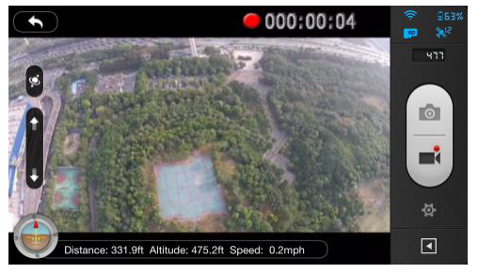](http://wiki.dji.com/en/index.php/File:P2v-record_button.png)

[12] **Camera Settings**

Tap to open thecamera settings menu, refer to <Camera Settings>.

[13] **Hide or Show Flight Parameters**

Tap to hide the flight parameters. Tap again to show.

#### Camera Settings

[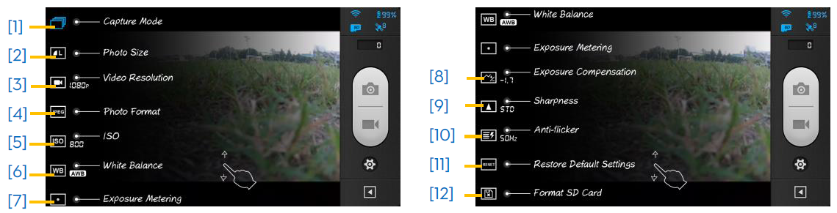](http://wiki.dji.com/en/index.php/File:P2v-camerasettings.png)

##### [1] Capture Mode

[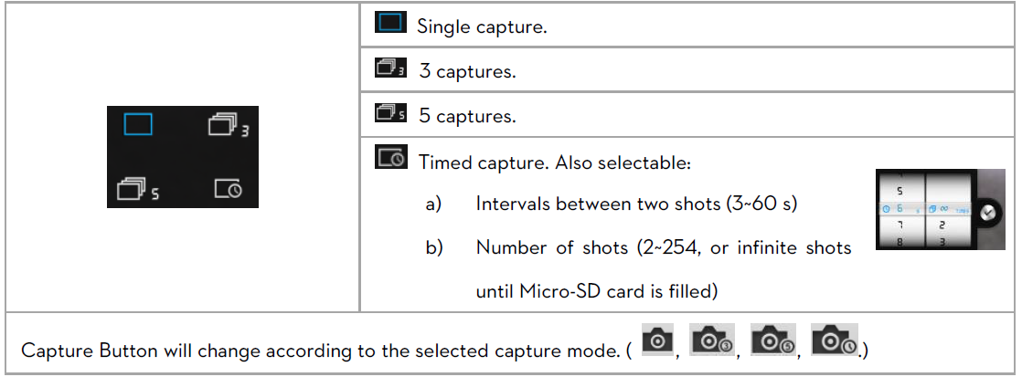](http://wiki.dji.com/en/index.php/File:P2v-camerasettings1.png)

##### [2] Photo Size

[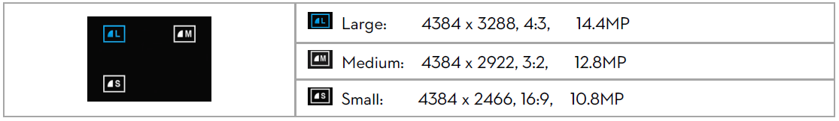](http://wiki.dji.com/en/index.php/File:P2v-camerasettings2.png)

##### [3] Video Resolution

[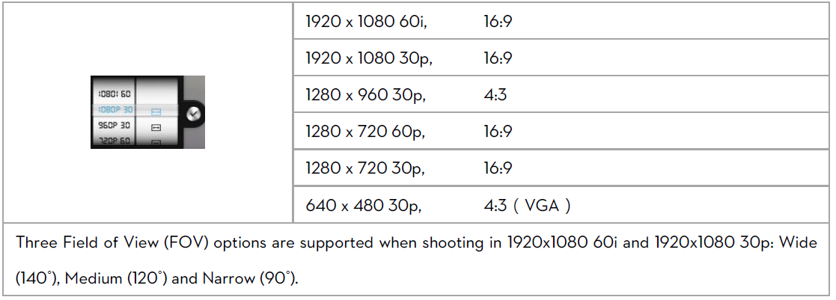](http://wiki.dji.com/en/index.php/File:P2v-camerasettings3.png)

##### [4] Photo Format

[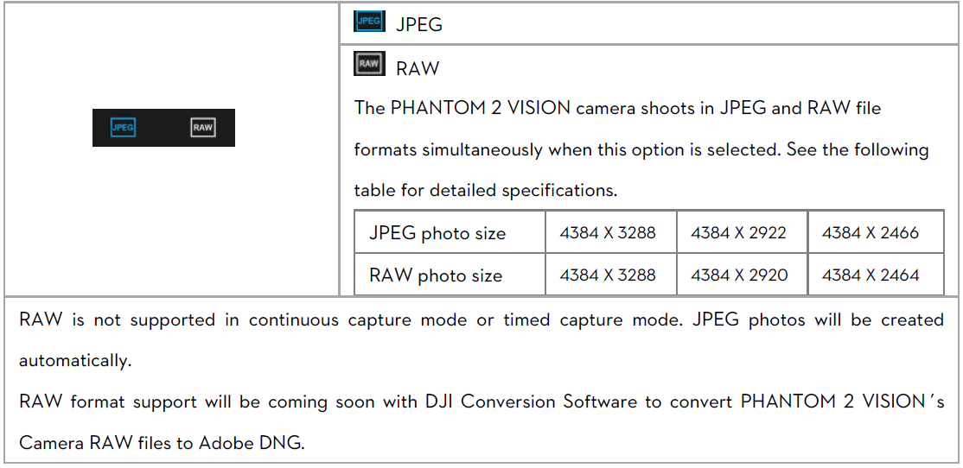](http://wiki.dji.com/en/index.php/File:P2v-camerasettings4.png)

##### [5] Selectable ISO

[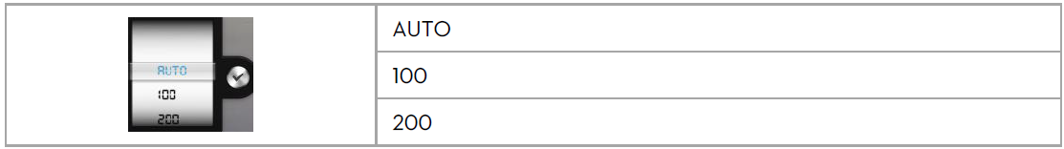](http://wiki.dji.com/en/index.php/File:P2v-camerasettings5-1.png)

[](http://wiki.dji.com/en/index.php/File:P2v-camerasettings5-2.png)

##### [6] White Balance

[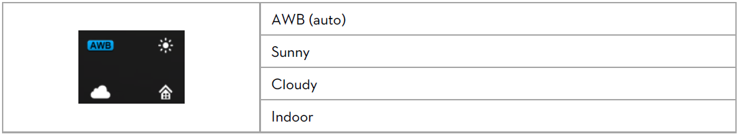](http://wiki.dji.com/en/index.php/File:P2v-camerasettings6.png)

##### [7] Exposure Metering

[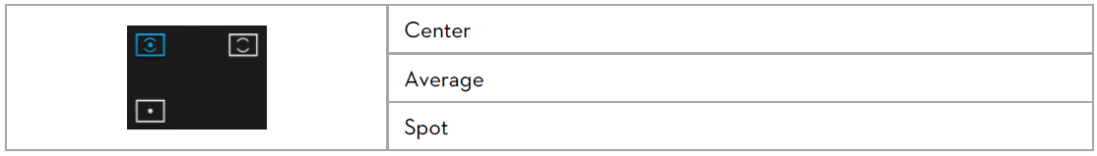](http://wiki.dji.com/en/index.php/File:P2v-camerasettings7.png)

##### [8] Exposure Compensation

[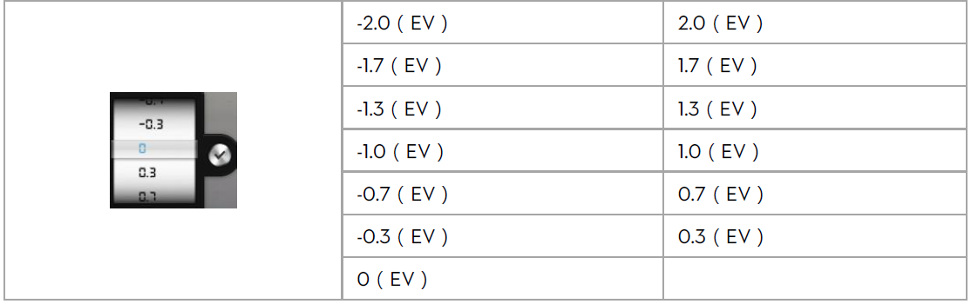](http://wiki.dji.com/en/index.php/File:P2v-camerasettings8.png)

##### [9] Sharpness

[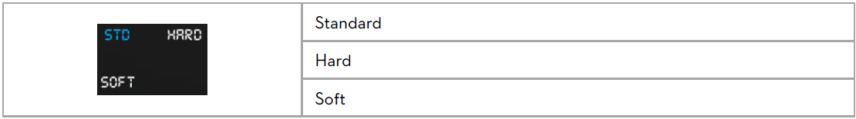](http://wiki.dji.com/en/index.php/File:P2v-camerasettings9.png)

##### [10] Anti-flicker

[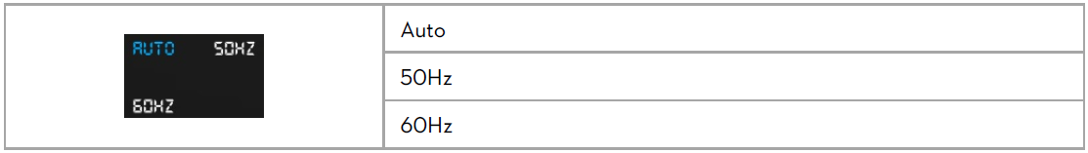](http://wiki.dji.com/en/index.php/File:P2v-camerasettings10.png)

##### [11] Restore Default Settings

Restores all camera default settings. Camera reboot is needed to allow restoration to take effect.

##### [12] Format SD Card

Format the Micro-SD card. All data stored in the Micro-SD card will be lost after formatting. Remember to backup before formatting.

### Album Page

#### Camera SD CARD Album

Browse thumbnails of photos and videos stored on the Micro-SD card. Tap to view photo or watch video.

[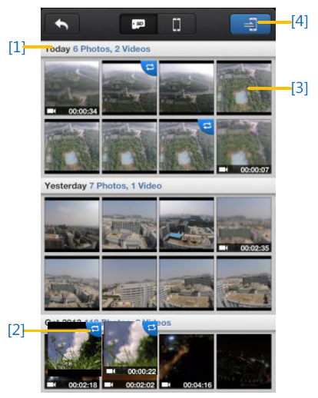](http://wiki.dji.com/en/index.php/File:P2v-albumpage.png)

# Appendix F: Advanced Techniques

This appendix concerns some of the more advance techniques the pilot can do when flying the drone

### Flying Curves

The ability to fly curves easily is a hard enough task to handle, however with the Home Lock and Course Lock settings the pilot can learn to fly curves with ease.

In order to fly curves:

1. Set a new Home Point to be away from the controller
2. Set CL to desired orientation
3. Fly beyond the CL radius from HP
4. Follow Home Lock directions in *Appendix B*
5. Once the drone enters CL radius it will immediately curve into the direction of the down directional of the CL set
6. Using the Throttle’s left or right spinning ability rotate the drone so it is pointed in whatever direction desired
7. As the drone turns in place it will continue to redirect in the backwards orientation of the CL

*Source:* (Time, #7, 2014)

### Regaining Control of the DJI Phantom while in the Air after a Fail Safe was initiated

Whenever the drone leaves the range of the controller, the battery is dying, or the controller is dead it will enter a Fail Safe protocol. The following steps only work when the drone regains range of the drone.

1. Turn off the controller – This initializes the Fail Safe protocol
   1. The drone’s LED will flash in accordance to the LED Error for loss of controller which can be found in *Appendix C*
2. Toggle the GPS\ATTI\ATTI setting to the first ATTI setting
3. Pull the Throttle down
4. Turn the controller back on
5. The controller’s power LED will flash several times and then go solid
6. Release the throttle
7. Control of Drone is regained.

**\*IMPORTANT* This technique should ONLY be done after several hours of training and in an open field**

*Source:* (Laur, 2013)

# Works Cited

(n.d.). Retrieved May 04, 2015, from deepimpact.umd.edu: https://s.yimg.com/fz/api/res/1.2/pBKWfhGz3eKQPy_033GuKQ--/YXBwaWQ9c3JjaGRkO2g9MjM1O3E9OTU7dz0yNTc-/http://deepimpact.umd.edu/webdings/icons/challenge_3DAxes.jpg

Administration, F. A. (2015, Febuary 17). *Unmanned Aircraft Systems (UAS) Frequently Asked Questions* . Retrieved Febuary 25, 2015, from Federal Aviation Administration: https://www.faa.gov/uas/faq/

DJI. (2013, September 25). *PHANTOM Quick Start Manual v1.7*. Retrieved April 29, 2015, from http://download.dji-innovations.com/downloads/phantom/en/PHANTOM_Quick_Start_Manual_v1.7_en.pdf

DJI. (2014, June 5). *Phantom 2 Vision-DJI Vision App Usage*. Retrieved May 14, 2015, from DJI Wiki: http://wiki.dji.com/en/index.php/Phantom_2_Vision-DJI_Vision_App_Usage

*Informer*. (n.d.). Retrieved Febuary 25, 2015, from http://img.informer.com/screenshots/4341/4341095_1.jpg

Institute, M. (2011). *Applications of Quadratic Functions*. Retrieved February 19, 2015, from Monterey Institute: http://www.montereyinstitute.org/courses/Algebra1/COURSE_TEXT_RESOURCE/U10_L2_T1_text_container.html

Keilman, J. (2014, October 24). *Drones used to capture high school football action*. Retrieved Febuary 26, 2015, from Chicago Times: http://www.chicagotribune.com/suburbs/elgin-courier-news/news/ct-high-school-football-drone-met-20141024-story.html#page=1

Laur, A. (2013, March 31). *DJI Phantom -Important ! How to Take Control in Air after Fail-Safe !!!* Retrieved April 29, 2015, from YouTube: https://www.youtube.com/watch?v=wI6fgmuk2rM

Mason, M. (n.d.). *Aerial Photography Principles and Applications*. Retrieved April 27, 2015, from Environmental Science.org: http://www.environmentalscience.org/principles-applications-aerial-photography

*Phantom 1 - Features | DJI*. (n.d.). Retrieved Febuary 20, 2015, from DJI: http://www.dji.com/product/phantom/feature

*RCGroups*. (n.d.). Retrieved Febuary 25, 2015, from http://static.rcgroups.net/forums/attachments/1/0/0/9/9/6/ai15841173-141-thumb-Asst8.jpg?d=1370651242

Time, T. T. (2014, May 19). *#5*. Retrieved April 29, 2015, from YouTube - #5 DJI Phantom Tutorial - IOC Course Lock (CL) Explained and Demostrated: https://www.youtube.com/watch?annotation_id=annotation_1577434411&feature=iv&src_vid=IYYVyRVGE-8&v=P9tncWssRns

Time, T. T. (2014, May 19). *#7*. Retrieved April 29, 2015, from YouTube - #7 DJI Phantom Tutorial - IOC Homelock (HL) Explained and Demostrated: https://www.youtube.com/watch?v=IYYVyRVGE-8

DJI PHANTOM I

# QUICK START FLIGHT GUIDE

Jake R Slaght

April 25 2015

Amended May 4, 2015

## Quick Start: Pre-Flight Checklist

The pre-flight checklist is important as most of the flight related issues can be handled before a flight demonstration.

#### Night before Flight Day

1. Ensure the Weather is going to be flight capable
   1. High winds, cold temperatures, low visibility and precipitation of any sort will halt flying the DJI Phantom immediately.
2. Plug in battery into wall charger and allow it to charge overnight.



Figure 35: Battery showing pins



Figure 36: Wall adapter -- Battery Connection



Figure 37: Proper Connection of battery to charger

(source: Author)

1. Plug in charger for controller batteries into wall and place batteries in it.
2. Plug and Charge the iPad being used for DJI VISION software
3. Turn on a laptop and ensure it will remain logged in and on.
4. Plug the camera into the laptop for charging.

***\*NOTE* Allowing the battery to charge overnight ensures full charger for a morning flight. Acquire a total of three mini USB charge cables for the charging the camera, for the drone and t`he remote for updating purposes***

#### Day of the Flight

1. Make note of current weather conditions
   1. If weather is bad postpone to the afternoon or the following day.
      1. Bad weather constitutes as rain, snow, high winds
2. Double check the drone battery is full charged
   1. Press the button on the front of the battery for a second the lights will flash up the power currently
      1. Battery must be unplugged from the wall charger to perform



Figure 38: Battery showing current power levels

1. Unplug and bring along all the charged batteries and camera.
2. Bring the Drone, iPad, batteries, and controller
3. Install the controller batteries now, do not install drone battery or turn on the controller until at location
4. Locate a wide open area with minimal buildings, electrical, or metal based structures as they will interfere with the configuration and calibration of the drone.
5. Refer to *Appendix E* for use of the camera

#### At Location of Flight

1. Place the drone on flight level ground and place the controller down as well.
2. Turn on the controller
   1. The controller must be on prior to powering up the drone for the drone and the controller to sync correctly to one another
3. Install battery into drone
   1. Press the battery button once and release
   2. Press and hold the battery button until it chirps, about five seconds
   3. If issues persist – Lights flashing red or beep codes please look at *Appendix C*.
4. Make sure all switches on the controller are positioned correctly
   1. The HomeLock/CourseLock switch on the left side should be set to ‘Off’
   2. The GPS/ATTI/ATTI switch on the right should be set to ‘GPS’
5. On the controller toggle the GPS/ATTI/ATTI switch 6 to 10 times until the LED light on the drone is a solid yellow-orange (here on out will be declared ‘Yellow’) and the toggle switch is on GPS
   1. This step should be done slowly to ensure switch ends correctly, otherwise repeat until correct
6. Perform the ‘Calibration Dance’ Ritual
   1. Pick up the Drone carefully so it is still horizontally positioned with arms out.

*\*NOTE* The images shown below are original images from the Phantom I documentation.*



Figure 39: Horizontal Setup of the Calibration Dance -- Yellow Light Revealed



Figure 40: Horizontal Holding, showing hand positioning

* 1. Very slowly walk in a counter-clockwise circle until the LED lights on the arms on the drone turns a solid Green
  2. Turn the drone vertically holding the legs and the camera is pointing to the ground



Figure 41: Starting the vertical calibration



Figure 42: Vertical holding -- showing arms to drone position

* 1. Very slowly walk in a counter-clockwise circle until the LED lights on the arms flashes yellow

1. Set down the drone and allow the GPS system and the satellites to sync.
   1. This step can take several minutes to complete, the light sequence is listed in *Appendix C*.
2. You are now ready for flying the DJI Phantom 2 drone
   1. Refer to *Appendix B* for Operating the Drone during Flight
3. If using the camera turn on the Extender.
   1. See Appendix E for configuration on the iPad and use.
4. Enjoy and Be Safe!

***\*NOTE* Video Guide of Pre-Flight Drone Operation provided, go to: [insert link]***

## Quick Start: Operating Drone during Flight

Once the Pre-Flight setup has been completed and the drone is ready to fly the steps below are fairly simple and probably the easiest to handle!

**\*IMPORTANT* See *Appendix E* in how to use the Camera**

*\*NOTE* The images shown below are original images from the Phantom I documentation.*

1. Start the Motors
   1. Pushing both joysticks down in opposite outside corners works best
      1. Throttle down and to the left
      2. Directional down and to the right



Figure 43: Starting motors

* 1. nce motors start, release the joysticks so they return to the center
  2. Allow the motors and rotors to spin for several seconds
  3. If any sounds or the motors slow down and stop spinning please review *Appendix C*

1. Once motors are going without issues ready for flight
2. Slowly apply upward pressure to the Throttle
   1. The motors will make a lot of noise at this point – this is normal
   2. Continue to apply throttle until drone starts lifting off the ground.
   3. Once drone is off the ground, applying more pressure will send it up into the air higher

After the above steps, the following steps are more of how-to move the drone

***\*NOTE* The direction of flight is determined by the direction of the nose of the drone. If nose is facing towards the pilot, the directional orientation is reversed and the left and right spins on throttle are reversed. Drone facing left the directional orientation is rotated 90° to the left. Drone facing right the directional orientation is rotated 90° to the right. See Course Lock functionality below.***

1. To Hover: Release the throttle, the drone will remain in a hover state as long as the wind isn’t too strong. It may move slightly.
2. To turn the drone around in either the left or right along it’s z-axis (up and down): Push the throttle stick to the left or right.
3. To move forward or backwards along the x-axis: Push the directional stick forward or pull it back
4. To move left or right on the y-axis: Push the directional stick left or right.



Figure 44: 3D Axis

*(source:* (deepimpact.umd.edu)*)*

1. To Land: Slowly pull the throttle down until the drone lands on the ground, keep the stick down, adjusting the directional stick as needed to keep the drone stable
   1. Keep the throttle stick pulled downward until the motors stop running.



Figure 45: Throttle Down -- Motor Kill Switch

#### Setting a Home Point (HP)

A home point is the location in which the drone will use as a home base for the Course Lock and Home Lock functions. The starting home point of any initial flight is the starting location of the controller. (Time, #7)

#### To Change a Home Point during Flight

1. Find new location clear of pilot
2. Toggle CL/HL switch between CL and HL 5 times. (Time, #7)

#### Setting and Using Course Lock (CL) Initially for Flight

Course Lock allows for the pilot to have the same directional control of the drone regardless of the nose’s physical pointing direction.

**\*IMPORTANT* CL can only be used within a 16 to 32 foot radius circle of the Home Point.**

To set the CL initially while in the field the pilot does the following:

1. With drone and controller off place the nose of the drone in the direction desired for forward.
2. Turn on the Drone and Controller in the fashion mentioned above
3. Allow GPS to sync to drone
4. Toggle the CL/HL toggle to CL and wait for the yellow flashing with green
5. CL is now set
6. To fly with CL now set toggle to off
7. Fly as normal

**\*IMPORTANT* Course Lock allows the pilot to use the same directional and spin directions of the throttle regardless of direction of the nose of the drone.**

*Source:* (Time, #5)

#### To reset CL during Flight

With the drone in flight and the pilot wants to shift the directional controls for easier orientation between the controller and the drone

1. Toggle CL On and Off 5 times until a flashing green light appears.
2. Return the toggle to Off
3. Fly as normal

*Source:* (Time, #5)

#### How to Use Home Lock (HL)

Home Lock allows for drone to return to the home. The location of the ‘home point’ is the location of the controller’s coordinates.

***\*NOTE\****

1. ***Home Lock is not for Failsafe control.***
2. ***HL is not automatic***
3. ***HL does not care about orientation of the drone, it will return towards the HP.***
4. ***HL only works outside of the CL range***

To use Home Lock the pilot would toggle the CL\HL to HL and pull down on the directional stick.

*Source:* (Time, #7)

**\*IMPORTANT* At any time the drone becomes out of the range of the controller, batteries run low on the drone the drone will enter a Fail Safe protocol which will send the drone back to the current home point.**

**\*IMPORTANT* If the pilot feels uncomfortable with the drone’s current flight patterns or loses sight of the drone see below about Home Lock**

***\*NOTE* The GPS location of the starting point is not 100% accurate due to the technology in use of the GPS system of the drone.***

***\*NOTE 2* To set Course Lock or Home Lock please see Appendix D on how to set the Intelligent Orientation Control settings in the NAZA-M software***

**\*IMPORTANT* See *Appendix F* for Advanced Techniques**

***\*NOTE* Video Guide of Drone Flight Operation provided, go to: [insert link]***

## Quick Start: LED/Sound Error Codes



Figure 46: LED Error Quick Reference Card

Figure 23 depicts the attached reference card that DJI provided with the controller for the Phantom 2. This is a huge change since the Phantom I due to the use of having something for in field use. The Phantom I did come with the LED codes but they were only contained within the start guide or available extensively online at the DJI website. The Phantom 2’s codes are also provided on their website and in the guide provided, but the reference card makes it easy for on field reference card.

## Quick Start: Phantom Software/NAZA-M Assistant Software

### The Phantom Software

Unlike the DJI Phantom I the second generation drone has its body of software that provides basic system setup for just the drone itself. To setup the Intelligent Orientation Controls and Fail Safe Settings please use the NAZA-M. The NAZA-M is now accessible for the Phantom 2 via selecting the word ‘Phantom’ as seen in Figures 49 to 51 – Read the below NAZA-M section for how to use the NAZA-M.



Figure 47: Phantom 2 Software Icon



Figure 48: Phantom 2 Software Splash Screen



Figure 49: Phantom 2 Overview



Figure 50: Phantom 2 Basic Tab



Figure 51: Phantom 2 Advanced Tab

Figures 49 to 51 provide basic information on how to setup the drone’s Gimbal, Limitations, Battery Overview, Controller, and basic configuration settings. The Battery Tab as seen in Figure 28 only provides an overview; it does not provided much in the way of configuration there besides the ‘Go-Home’ option.

### The NAZA-M Software

The use of the NAZA-M Software for the Phantom 2 requires the same settings as the Phantom I. The NAZA-M requires the controller to be connected to the drone. This implies power to the Drone and the controller (See *Quick Start sections: Pre-Flight Checklist and Operating Drone during Flight*) for details of connecting the controller to the drone). In addition to that connection please be sure to connect the drone, controller, and camera right to the laptop for software update control.

*NOTE* There is only a single USB available at the time of writing this, please ensure that the user has enough cables available to ensure all devices are connected.

For the Phantom 2 the NAZA-M software is used for more advanced settings such as the IOC.

1. Open the NAZA-M software



Figure 52: NAZA-M Splash Screen

(source: Author)

1. Upon boot up of the NAZA-M the user gets an over view of all settings



Figure 53: NAZA-M Overview Screen

(source: Informer (Informer))

1. The user can ensure the calibration of the controller for fine tuning control under the Basic Tab and RC
   1. In Figure 11 the following labels correlate to the following toggle switches and joysticks of the controller:
      1. A : Directional
      2. E: Directional
      3. T: Throttle
      4. R: Throttle
      5. U: GPS/ATTI/ATTI
      6. X1: HL/CL toggle
      7. X2: GPS/ATTI/ATTI toggle



Figure 54: Controller Settings

(source: Author)

1. To set the Intelligent Orientation Control settings for Home Lock and Course Lock the user accesses the Advanced tab under To allow for the drone to return upon battery dying or the loss of controller communication the user accesses the Failsafe Settings under the Advanced Settings.
   1. This setting also plays hand in hand with the battery settings the user can locate under Advanced > Voltage



Figure 55: Failsafe Settings

*(source: Author)*



Figure 56: Battery Settings

(source: Author)

#### Configuring the Intelligent Orientation (IOC) Settings



Figure 57: IOC Settings Screen

*(source:* (RCGroups)*)*

The IOC settings are required to utilize the Home Lock and Course Lock functions during flight usage. See *Appendix B* for Home Lock and Course Lock control.

The only step required to configure the IOC is to check the box for it at the top.

* The X2 indicated is the CL/HL toggle switch found on the controller, if toggled the slider will indicate the setting selected within the software.

## Quick Start: How to Use the Camera

Connecting the drone’s camera to the iPad is an extremely easy process, controlling the camera is a different story entirely when comparing it to the GoPro and the Phantom I.

### Connect to the Camera

Follow the steps found in Appendix A of setting up the drone for flight. Prior to taking off turn on the Extender via the power switch on the side of it.

The Phantom 2’s wireless system for the camera is ***Phantom_JaguarVision***.

Follow DJI’s guide below for how to use the device, it is actually really good

### DJI’s Guide of how to use the Camera

The following write up how to use the camera comes from the DJI Wiki Page concerning the Camera. The author takes no credit of writing it. Anything inputted by the author will be marked with a bolded **Author:** marking.

*(source:* (DJI, 2014)*)*

After login you will come to the main page. This shows the current Wi-Fi connection and four app function icons.

[](http://wiki.dji.com/en/index.php/File:P2v-App_Main_Menu.png)

**Caution**

1.Connect your mobile device to the PHANTOM 2 VISION Wi-Fi network to use the camera and onboard album.

2.Connect your mobile device to the internet (mobile or Wi-Fi) to share photos,videos and read DJI news.

3.If you receive a phone call during flight, the live camera preview screen may be interrupted. It's recommended to ignore the call and pay full attention to your flight. **Author: This is not going to be a problem, disregard. GVCS uses an Apple iPad**

#### Basic Use

[](http://wiki.dji.com/en/index.php/File:P2v-Basic_Use.png)

[1] **Return**

[](http://wiki.dji.com/en/index.php/File:P2v-return.png) - Return to the preview page

[2] **Camera Tilt Control**

[](http://wiki.dji.com/en/index.php/File:P2v-tilt.png) - Tilt Control Mode. Tap and hold to enter the Accelerometer Sensor Mode.Release to return to normal mode.

[](http://wiki.dji.com/en/index.php/File:P2v-tilt.png) **Normal Mode**

Tap up arrow ([](http://wiki.dji.com/en/index.php/File:P2v-tilt_up.png)) to pitch camera upwards and down arrow ([](http://wiki.dji.com/en/index.php/File:P2v-tilt_down.png)) to pitch downwards. Green slider indicates current camera pitch.

[](http://wiki.dji.com/en/index.php/File:P2v-tilt_mode.png)

[](http://wiki.dji.com/en/index.php/File:P2v-tilt_on.png) **Accelerometer Sensor Mode**

Tap and Hold to switch on Accelerometer Sensor Mode to control camera pitch and rotation by moving your mobile device.

Tilt device forward to pitch camera downward and backward to pitch upward. Lean it left to rotate left ([](http://wiki.dji.com/en/index.php/File:P2v-turn.png)) and right to rotate right ([](http://wiki.dji.com/en/index.php/File:P2v-turn.png)).

[](http://wiki.dji.com/en/index.php/File:P2v-tilt_motion.png)

**Caution**

In Accelerometer Sensor Mode, the pitch angle indicator will show a grey area. When the green pitch indicator is inside the grey area, the camera will move according to pitch gestures. When the indicator is outside of the grey area, pitch gestures will control the camera’s pitch speed. The bigger the gesture of the mobile device, the faster the camera will move.

[3] **Flight Attitude and Radar Function**

Flight attitude is indicated by the flight attitude icon.

(1) The red arrow shows which direction the PHANTOM 2 VISION is facing.

(2) Blue and brown areas indicate its pitch.

(3) Tilting of the brown and blue area shows roll angle.

[](http://wiki.dji.com/en/index.php/File:P2v-Radar_Function.png)

Tap the flight attitude icon to turn on the radar function. Home is located in the center of the radar and the red icon indicates the PHANTOM 2 VISION’s current heading, direction, and approximate distance from home. Tap the flight attitude icon again to disable the radar.

[](http://wiki.dji.com/en/index.php/File:P2v-Radar_Function1.png)

**Caution**

1.By default, the center of the radar indicates the home point that has been recorded by the PHANTOM 2 VISION. Tapthe center of the radar to switch the center to your mobile device's current location.

2.If your mobile device contains a compass, the top portion of the Radar is the direction you are pointing. If not, the radar will be oriented due north.

[4] **Flight Parameters**

Distance: Horizontal distance from home point.

Altitude: Vertical distance from home point.

Speed: Horizontal flying speed.

**Tips:** Distance will appear as NA if the PHANTOM 2 VISIONis not Ready to Fly.

[5] **Wi-Fi Signal Intensity**

Indicates camera is connected to your mobile deviceand Wi-Fi is working normally.

The connection between the camera and mobile device may fail if Wi-Fi signal strength is low. Refer to the <PHANTOM 2 VISION CONNECTION BROKEN>on the camera page.

[6] **Aircraft Battery Level**

(1) When available power is more than 30%, the battery icon is blue (e.g. [](http://wiki.dji.com/en/index.php/File:P2v-battery_percentage.png)). This battery level is appropriate for flight.

(2) When below 30%, the battery icon will turn red (e.g. [](http://wiki.dji.com/en/index.php/File:P2v-battery_percentage1.png)) and the LED flight indicator will slowly blink red. This battery level is low for flight.It is recommended that you fly your PHANTOM 2 VISION home and land it as soon as possible.

(3) After available power drops below 20%(e.g. [](http://wiki.dji.com/en/index.php/File:P2v-battery_percentage2.png)), there is no longer enough power for flight. The LED flight indicator will begin to flash red rapidly and the PHANTOM 2 VISION will begin an automatic descent and land.

**Caution:** The available power thresholds mentioned above can be adjusted in the PHANTOM 2 VISION assistant software.

[7] **Aircraft GPS Status**

Displays GPS status and the number of available satellites. The icon is highlighted when more than 6 satellites are found, enabling Ready to Fly mode.

[8] **Micro-SDCard Status**

DisplaysMicro-SD Card Status. The icon is highlighted when a valid Micro-SD card is inserted. If there is no Micro-SD card present, it is grayed out.

[9] **RemainingShots**

Displays estimated shots remaining, based on the current Photo Sizesetting of camera and the storage capacity of the Micro-SD card. This shows ‘0’ if:

(1) Micro-SD card is not inserted.

(2) Micro-SD card is full.

(3) Micro-SD card is damaged.

(4) Connection between the DJI VISION App and camera is broken.

[10] **Shutter Button**

Tap to take photos.

Single capture: press once for a single capture.

Continuous capture: press once for 3 or 5 captures.

Timed capture: press once to begin a timed capture, press again to stop.

**Caution:**

(1)Shutter button is disabled during video recording.

(2)Capture modes can be reconfigured in camera settings; refer to the<Camera Settings>.

[11] **Record Button**

Start and Stop video recording. Tap once to start recording. Ared dot will blink to indicate recording is in progress and a time elapsed counter will appear in the top right corner of the preview screen. Press again to stoprecording.

[](http://wiki.dji.com/en/index.php/File:P2v-record_button.png)

[12] **Camera Settings**

Tap to open thecamera settings menu, refer to <Camera Settings>.

[13] **Hide or Show Flight Parameters**

Tap to hide the flight parameters. Tap again to show.

##### Camera Settings

[](http://wiki.dji.com/en/index.php/File:P2v-camerasettings.png)

###### [1] Capture Mode

[](http://wiki.dji.com/en/index.php/File:P2v-camerasettings1.png)

###### [2] Photo Size

[](http://wiki.dji.com/en/index.php/File:P2v-camerasettings2.png)

###### [3] Video Resolution

[](http://wiki.dji.com/en/index.php/File:P2v-camerasettings3.png)

###### [4] Photo Format

[](http://wiki.dji.com/en/index.php/File:P2v-camerasettings4.png)

###### [5] Selectable ISO

[](http://wiki.dji.com/en/index.php/File:P2v-camerasettings5-1.png)

[](http://wiki.dji.com/en/index.php/File:P2v-camerasettings5-2.png)

###### [6] White Balance

[](http://wiki.dji.com/en/index.php/File:P2v-camerasettings6.png)

###### [7] Exposure Metering

[](http://wiki.dji.com/en/index.php/File:P2v-camerasettings7.png)

###### [8] Exposure Compensation

[](http://wiki.dji.com/en/index.php/File:P2v-camerasettings8.png)

###### [9] Sharpness

[](http://wiki.dji.com/en/index.php/File:P2v-camerasettings9.png)

###### [10] Anti-flicker

[](http://wiki.dji.com/en/index.php/File:P2v-camerasettings10.png)

###### [11] Restore Default Settings

Restores all camera default settings. Camera reboot is needed to allow restoration to take effect.

###### [12] Format SD Card

Format the Micro-SD card. All data stored in the Micro-SD card will be lost after formatting. Remember to backup before formatting.

#### Album Page

##### Camera SD CARD Album

Browse thumbnails of photos and videos stored on the Micro-SD card. Tap to view photo or watch video.

[](http://wiki.dji.com/en/index.php/File:P2v-albumpage.png)